
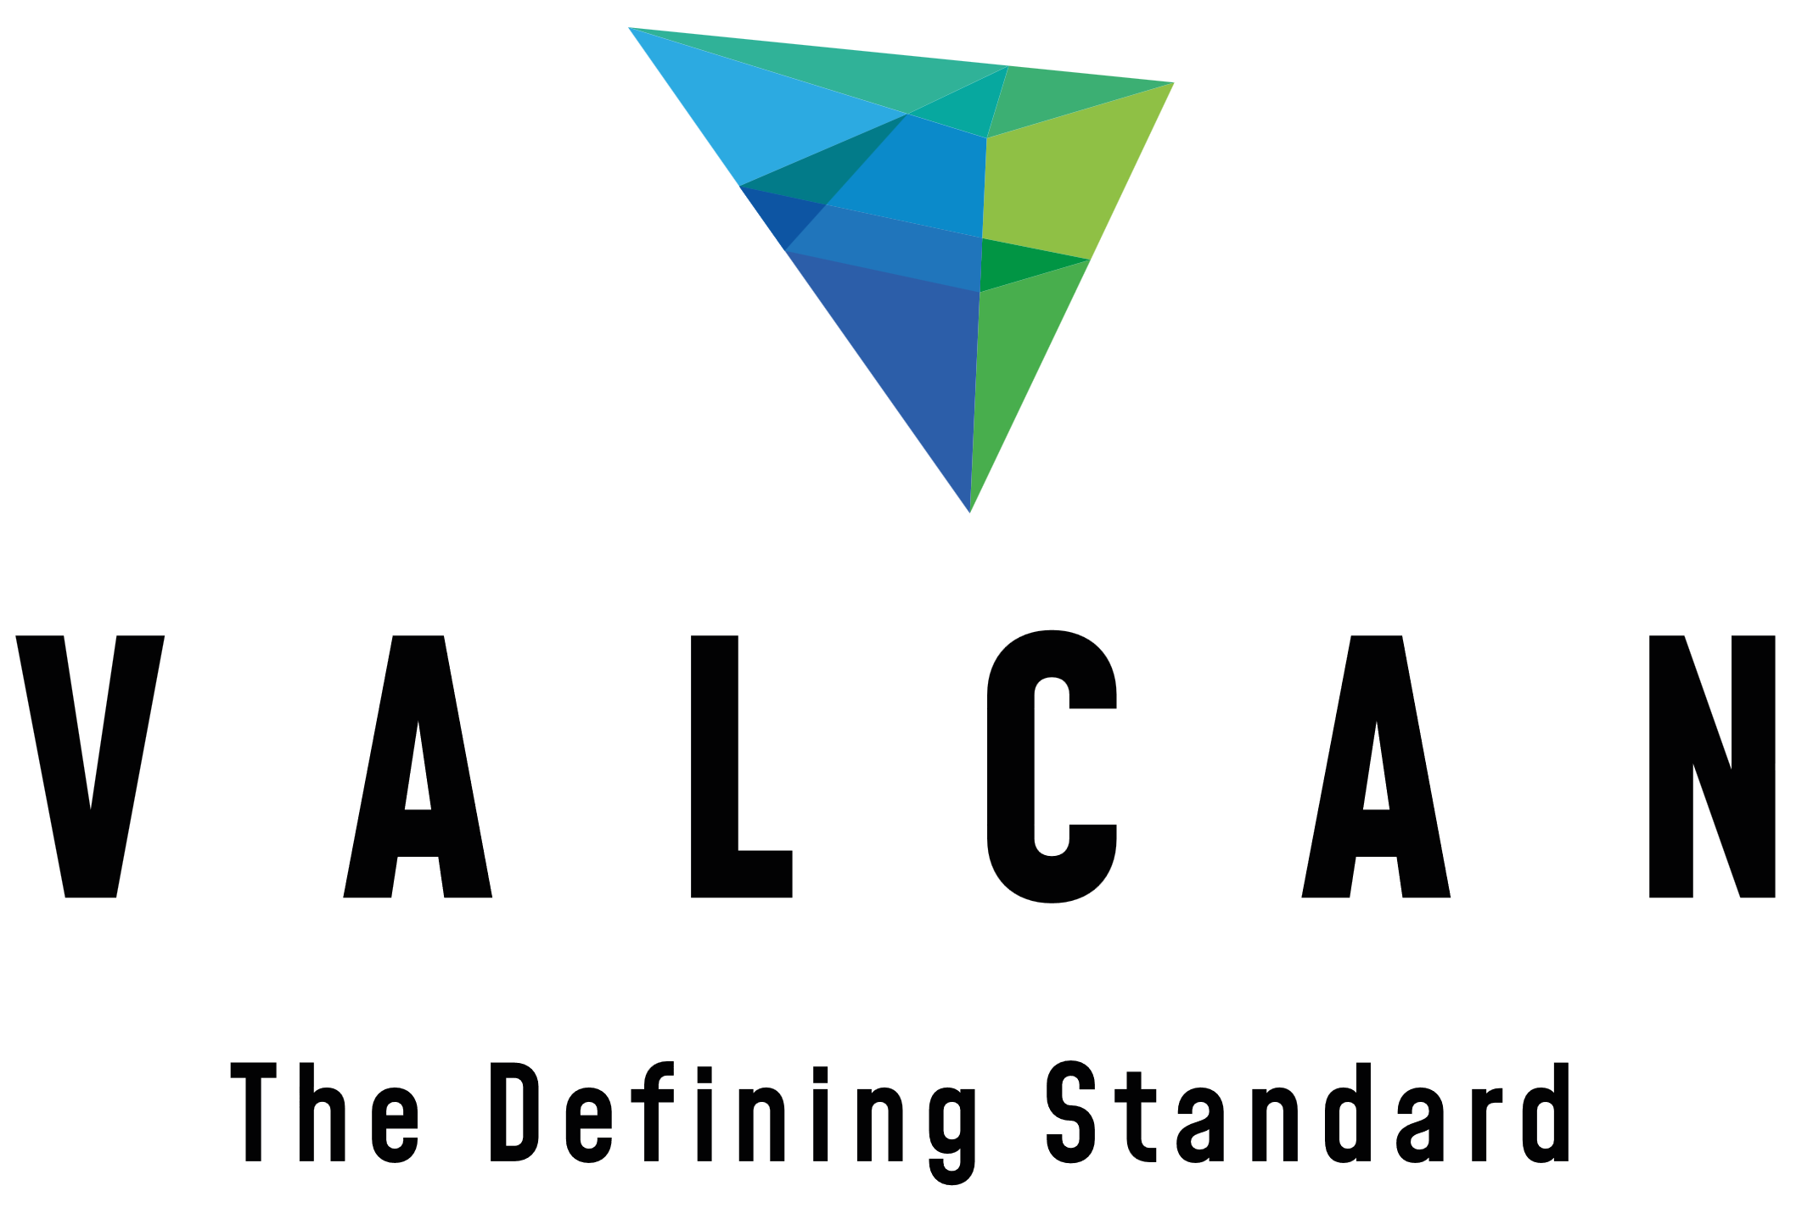
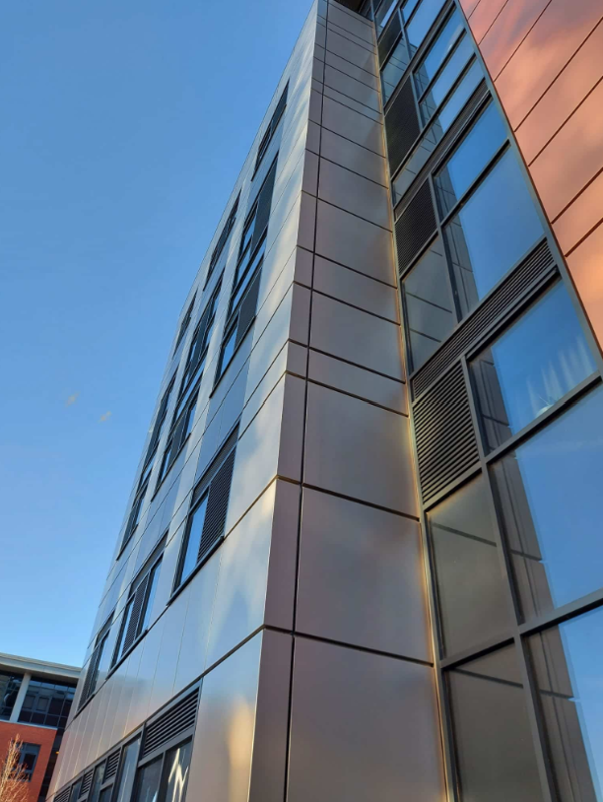

Specifications for NBS Chorus
VitraDual & VitraFix (VF1/VF2) Cassette Fix System



SUMMARY
System name: VitraDual Cassette Fix Rainscreen System
System basis of design: VitraDual A1 aluminium cassette panels installed on the VitraFix carrier system.
Manufacturer: Valcan with approved partner system components
System type: A1 aluminium cassette fix rainscreen façade
Fixing method: Secret / cassette fix
Fire rating: A1 throughout (panels, carrier, insulation, membrane)
Warranty: Up to 30 years
Typical applications: Residential, commercial, high-rise
Standards: BS 8414 tested, CWCT, BBA certified*

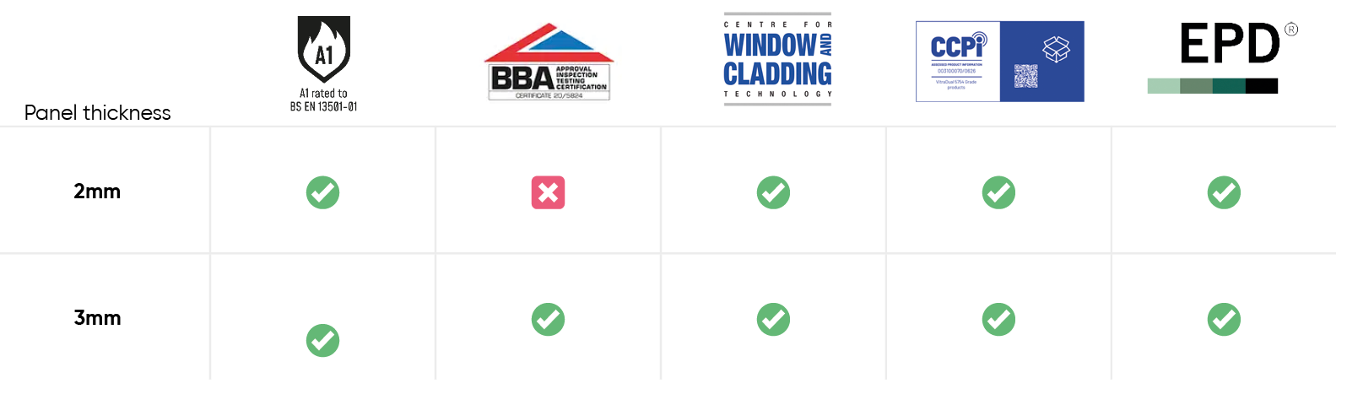

* Vitradual 3mm is manufactured by Valcan and is available with BBA certification when produced at BBA-certified production facilities. Certification requirements must be specified at enquiry and order stage. Contact us for more details

CONTENTS
VITRADUAL A1 ALUMINIUM CASSETTE RAINSCREEN SYSTEM | P 4-5
System description
Panel description
Performance
Finish and colour
Application
Specifiers notes – VitraDual | P 6
VITRAFIX ALUMINIUM CARRIER SYSTEM OVERVIEW | P 7-8
System description
Performance and compliance
System options
Application
TYPICAL DRAWINGS | P 9-11
Cassette fix typical joint
Cassette fix horizontal joint
Cassette fix external corner
Cassette fix internal corner
Specifiers notes - VitraFix | P 10
TECHNICAL SCHEDULE | P 11 – 15
System summary
Primary cladding details
Panel Fixings and stiffening
Carrier System – Primary Support
Horizontal rails (if required)
Joints and tolerances
Cavity and ventilation
Ancillary components
Masonry fixings (if required)
TECHNICAL DOWNLOADS | P 16
ADDITIONAL RESOURCES | P 17
Contact details | P 18

VITRADUAL A1 ALUMINIUM CASSETTE RAINSCREEN SYSTEM
SYSTEM DESCRIPTON
VitraDual is a non-combustible aluminium cassette fix rainscreen façade system, based on folded aluminium cassette panels with concealed fixings, installed onto an aluminium carrier system. The system is designed to provide a flat, durable and architecturally refined façade solution suitable for use on high-rise and low-rise buildings.
The system is eligible for a single-point, system-based warranty when supplied and installed in accordance with manufacturer’s recommendations.
PANEL DESCRIPTION
VitraDual panels are manufactured from solid aluminium and formed as folded cassette units with concealed fixings located within panel reveals or joints.
- Material: Aluminium alloy (5754 marine-grade)
- Thickness:
  - 2.0 mm (cassette fixing only)
  - 3.0 mm
- Fire classification: Classified A1 in accordance with BS EN 13501-1
- Fixing method: Secret-fixed cassette system
- Surface flatness: Extremely flat finish with low surface stress and no oil-canning effect when designed and installed in accordance with manufacturer guidance.
Panels may be manufactured to bespoke sizes and formats, including curved or perforated panels, subject to project requirements and structural assessment.
PERFORMANCE
Fire performance: Non-combustible system suitable for use in buildings subject to ADB v2 requirements.
Wind loading: CWCT tested and accredited to a safety loading of 3600 Pa (subject to project-specific calculations).
Thermal Conductivity: 138 W/mK
Durability: High impact resistance and suitable for use in high-traffic locations.
Certification: 3mm BBA certified* (Certificate No. 20/5824).
Final system performance is subject to project-specific structural calculations and façade design.
* Vitradual 3mm is manufactured by Valcan and is available with BBA certification when produced at BBA-certified production facilities. Certification requirements must be specified at enquiry and order stage. Contact us for more details

FINISH AND COLOUR
Panels are factory finished with high-performance PVDF Kynar 500 or FEVE paint systems, providing excellent resistance to weathering, UV exposure and atmospheric pollutants.
Colour range: Standard and bespoke colours available.
Maintenance: Low maintenance compared to polyester-coated alternatives.

APPLICATION
The VitraDual system is suitable for use on both internal and external façades of commercial, residential and industrial buildings where a clean, modern architectural appearance is required.
Typical applications include:
- High-rise residential buildings
- Commercial offices
- Mixed-use developments
- Areas requiring robust, non-combustible façade materials

Specifiers notes:
General: Specifier to confirm system configuration, panel dimensions and fixing strategy in conjunction with the manufacturer to suit project-specific structural, fire and environmental requirements.
Fire Performance: The VitraDual system is non-combustible and achieves a fire classification of A1 to BS EN 13501‑1. System build-up, including insulation, cavity barriers and breather membrane, shall be coordinated to ensure compliance with Approved Document B (ADB) and project fire strategy.
Panel Size and Layout: Maximum panel dimensions, joint spacing and cassette profiles are subject to wind loading, substrate condition and fixing centres. Final panel sizes shall be confirmed through project-specific calculations and manufacturer approval.
Wind Loading and Structural Design: Bracket type, spacing and panel support shall be determined based on site wind load calculations in accordance with CWCT guidance. Reference wind load testing is to 3600 Pa safety loading; higher or project-specific loadings may require design adjustment.
Finish and Colour Selection: Final colour, gloss level and coating system (PVDF Kynar 500 or FEVE) to be selected from the manufacturer’s standard or bespoke ranges. Colour selection may influence lead times and warranty duration.
Cavity Depth and Fire Barriers: Minimum cavity depths to be maintained in accordance with CWCT guidance, fire barrier requirements and airflow performance. Cavity depth reductions may be required at fire barrier locations and other pinch points and shall be coordinated at detailed design stage.
Thermal Bridging: Thermal isolators or pads may be required at bracket locations to limit cold bridging in accordance with project thermal performance requirements.
Warranty: Manufacturer warranty of up to 30 years is available, subject to system configuration, coating specification and compliance with Valcan installation guidance.
Coordination: Window interfaces, movement joints, flashings and terminations shall be detailed in coordination with adjacent façade elements to ensure continuity of fire performance, weather resistance and visual alignment.

VITRAFIX ALUMINIUM CARRIER SYSTEM OVERVIEW
The following carrier system details describe a typical aluminium support system suitable for cassette-fixed A1 rainscreen façades, illustrated using the VitraFix carrier system.

SYSTEM DESCRIPTION
VitraFix is an aluminium carrier system comprising brackets, rails and fixings designed to support non-combustible rainscreen cladding systems. The system is tested to BS 8414-1 and BS 8414-2 and assessed by the Centre for Window and Cladding Technology (CWCT).
The system is designed to provide a cost-effective, durable and adjustable support solution suitable for use across a wide range of building types and substrates.

PERFORMANCE AND COMPLIANCE
Fire performance: Tested to BS 8414-1 and BS 8414-2 as part of an external wall system.
Structural assessment: CWCT tested (subject to project-specific calculations).
Durability: Aluminium components designed for long-term external use.
Warranty: A system warranty is available when specified and installed in accordance with manufacturer’s requirements.

SYSTEM OPTIONS
VitraFix VF1 – Primary Bracket System
VitraFix VF1 is an adjustable aluminium bracket system designed to accommodate variations in substrate tolerance and cavity depth.
- Adjustability: 102–235 mm
- Application: Direct bracket fixing to structural substrate
- Extensions: Additional depth may be achieved by incorporating the VitraFix VF2 system components.
- Options: Custom bracket depths are available subject to project requirements.
VF1 is typically used as the primary carrier system for cassette-fixed rainscreen façades.

VitraFix VF2 – Rail and Secondary Support System
VitraFix VF2 comprises aluminium or steel top-hats and C-channel rails designed to provide additional system depth or allow brackets to be installed independently of stud locations.
- Enables alignment of the carrier system where stud positions are restrictive
- Can be used to increase overall system build-up depth
- Top-hats may be used independently as an alternative to timber batten sub-grids
VF2 components may be used in conjunction with VF1 brackets or as part of a secondary support arrangement, subject to design requirements.

APPLICATION
The VitraFix carrier system is suitable for use with non-combustible rainscreen façade systems on residential, commercial and mixed-use buildings. Final system selection, bracket spacing and fixing strategy shall be determined by project-specific structural and wind load calculations.

Specifier’s Notes:
Bracket type, spacing and material selection to be confirmed based on substrate, cavity depth and wind load calculations.
Movement joints and tolerance allowances to be incorporated in façade design to accommodate thermal expansion, substrate movement and building deflection.

TYPICAL DETAILS
Details shown are indicative only and shall be developed to suit project‑specific geometry, substrate and fire strategy.
CASSETTE FIX DETAILS SHOWING TYPICAL JOINT
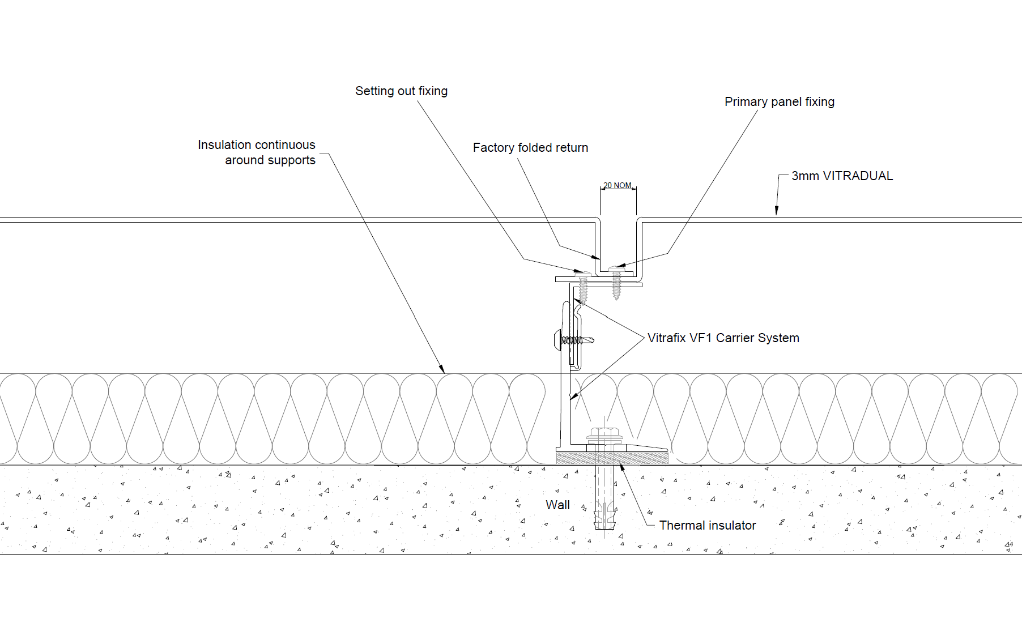
CASSETTE FIX DETAILS SHOWING HORIZONTAL JOINT
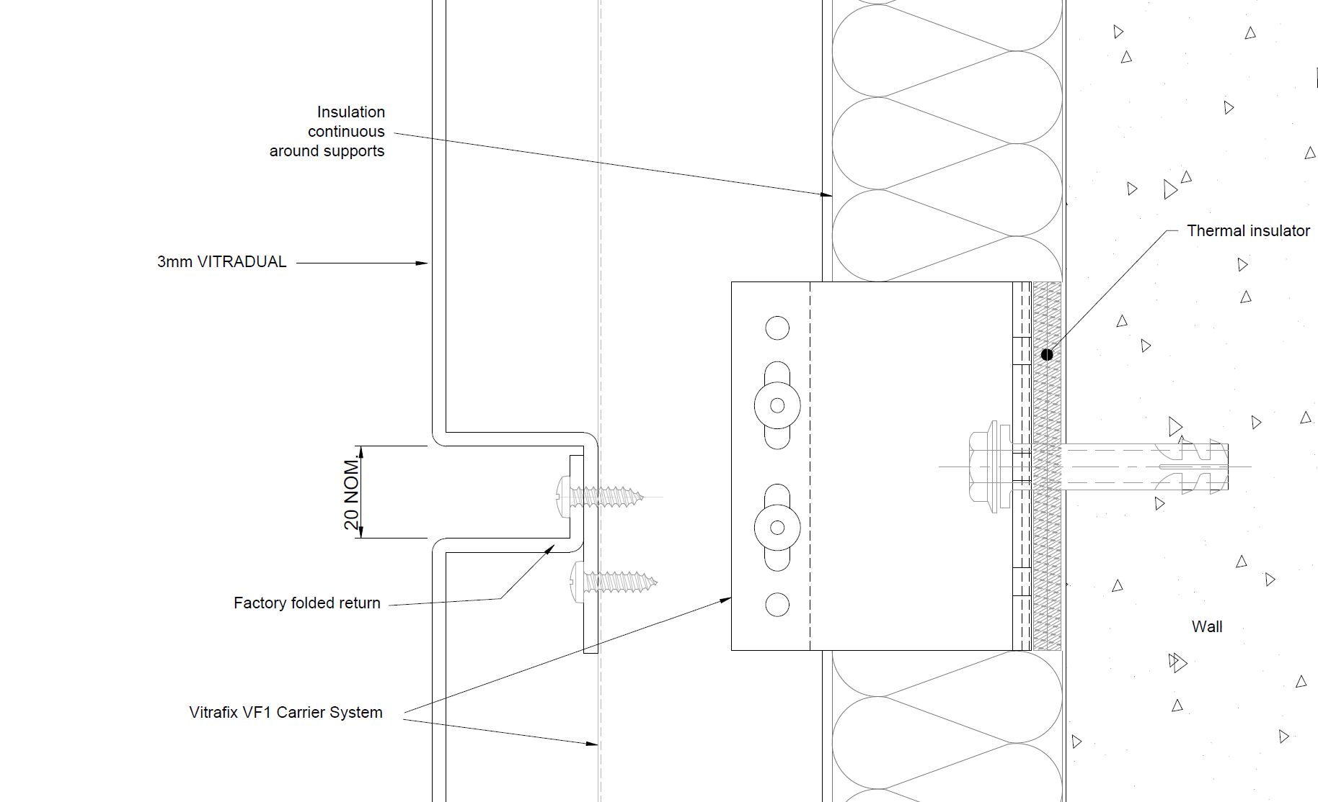

CASSETTE FIX DETAILS SHOWING EXTERNAL CORNER
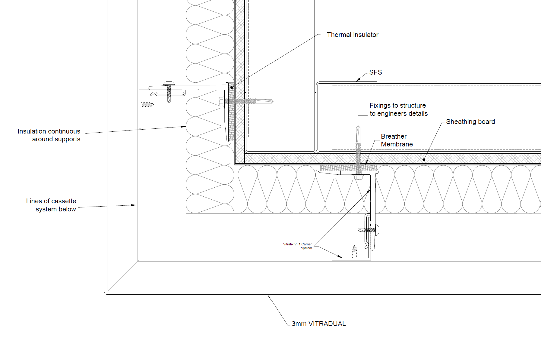
CASSETTE FIX DETAILS SHOWING INTERNAL CORNER
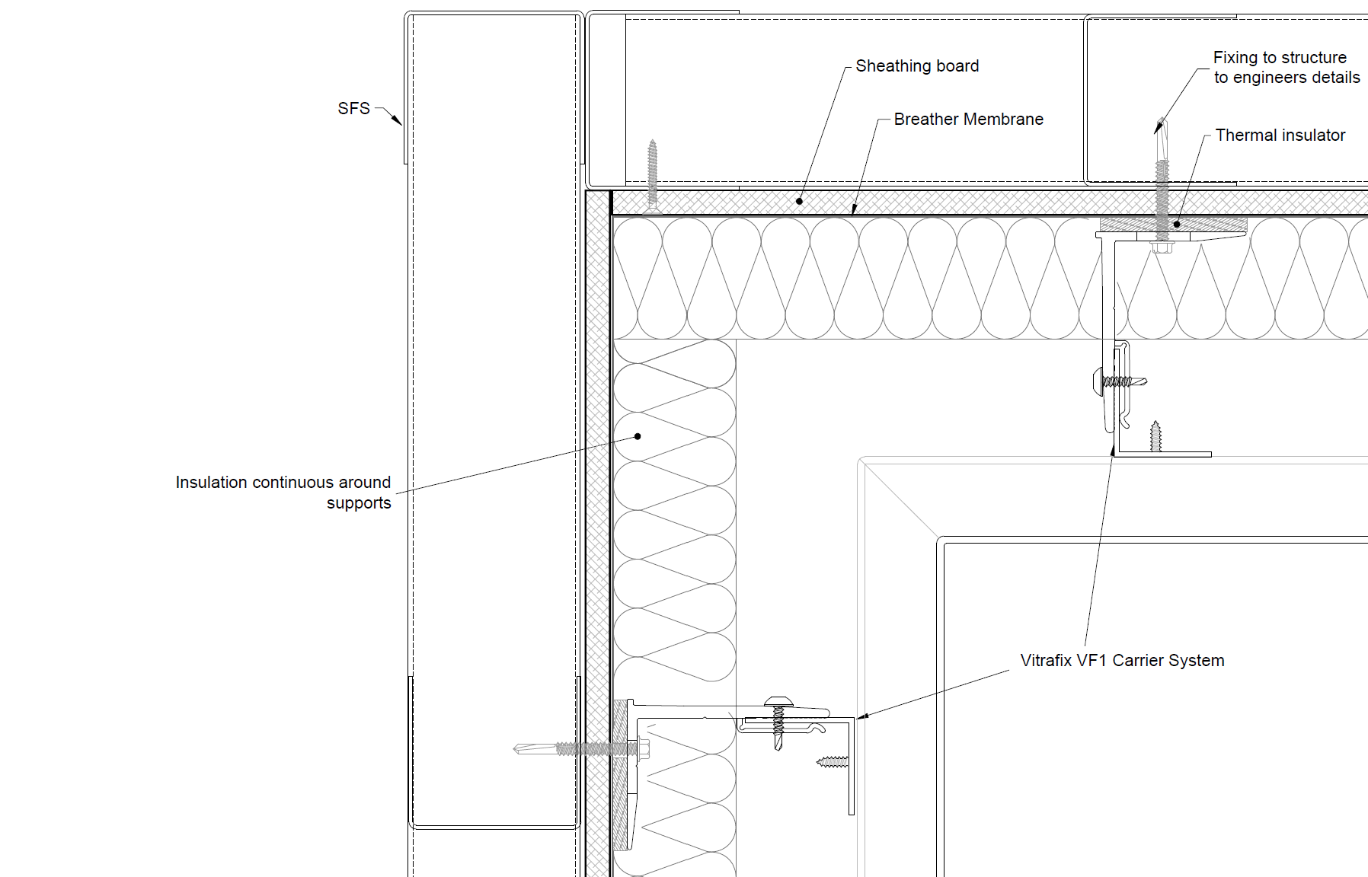
All Technical Details can be found at https://valcan.co.uk/wp-content/uploads/2026/02/VitraDual-Typical-Details-2026.zip or on request.

TECHNICAL SCHEDULE
Purpose of this schedule
This Technical Schedule provides detailed system components and reference information to support detailed design, coordination and installation.
Final configuration, sizing and fixing arrangements shall be confirmed by project-specific calculations and manufacturer approval.
1. SYSTEM SUMMARY
- Façade system name: VitraDual Cassette System
- System type: Aluminium cassette rainscreen façade system
- Primary carrier system: VitraFix VF1 / VF2
- Fire classification (overall system intent): A1
- Applicable standards: CWCT, BBA
(Informational summary only – see sections below for component detail)

2. PRIMARY CLADDING DETAILS
Product reference: VitraDual Cassette Fix
Manufacturer: Fairview Europe t/a Valcan
Product name: VitraDual
Material: 5754 grade aluminium
Thickness and Weight:
- Thickness: 3mm
- Weight (kg/m²): 8.13 kg/m².
Panel Dimensions:
- Indicative maximum panel sizes up to 5000 mm x 1500 mm, subject to wind loading, handling and cassette geometry.
- Depth – 20-40mm deep according to design
Fire Performance:
- Classification to BS EN 13501-1: Classified A1

3. PANEL FIXING AND STIFFENING
3.1 PRIMARY PANEL FIXINGS
 | Rail/fixing type | Reference | Sizes
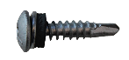 | VitraFix Self Drill Panhead A4, colour matched to panel | VFSDP5.535C | 5.5x35mm (200 box)

Panel Stiffening:
- Stiffener type: 2mm aluminium top-hat attached to reverse of panel using stud weld fixings
4. CARRIER SYSTEM
Carrier system reference: VitraFix VF1
- Manufacturer: Fairview Europe t/a Valcan
Material: Aluminium
System Description: Brief description of role within façade build-up
 | Bracket Reference | Size | Adjustment Range
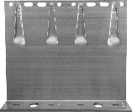 | VF140DB | 65 mm-260 mm double bracket | 142–172 mm
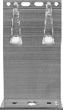 | VF140SB | 65mm-260 mm single bracket | 142–172mm
4.1 BRACKETS
Bracket selection and spacing subject to structural and wind load calculations.
4.2 THERMAL/ISOLATION PADS
 | Bracket Reference | Size | Adjustment Range
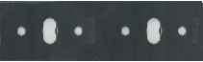 | VFIPDB | Double bracket thermal pad | 3 mm
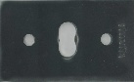 | VFIPSB | Single bracket thermal pad | 3mm

4.3 RAILS
 | Rail type | Reference | Sizes
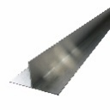 | T-Rail | VFTR503 / VFTR506 | 50 x 100 x 3000 mm / 50 x 100 x 6000 mm
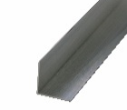 | L-Rail | VFLR503 / VFLR506 | 50 x 50 x 3000 mm /  50 x 50 x 6000 mm

5. HORIZONTAL RAILS (IF APPLICABLE)
System reference: VitraFix VF2
Purpose: VF2/U attached to SFS locations allowing brackets to be installed in isolation to stud location
Typical Applications: Not required for masonry
5.1 RAILS AND FIXINGS
 | Rail/fixing type | Reference | Sizes
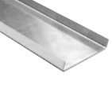 | U-Rail | VF2/U | 90x15x2mm / 174x15x2mm
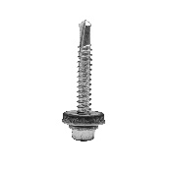 | VitraFix Self Drill Hex head with washer | VFSD.538/A4 | 5.5x38mm
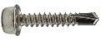 | VitraFix Self Drill Hex head | VFSD4.825 (See manufacturers details for fixing centres) | 4.8x25mm, 8mm
 | Masonry anchors - ETA approved fire-rated fixing | Valcan partner approved fixings

6. JOINTS AND TOLERANCES
Panel Joint Type:
- Typically 20mm Shadow Gap
- Closed joints

7. CAVITY AND VENTILATION
Cavity Depth:
- Minimum of 25 mm closed joint installation - measured from face of insulation to rear of panel, can be reduced by 50% at fire barrier locations or other “pinch” points. (Check with insulation supplier on suitability of cavity depth for their product)
- [other] - consult CWCT section 3.4.4.4
Ventilation Strategy:
- Closed state
- Refer to CWCT guidance where applicable

8. ANCILLARY COMPONENTS
8.1 SHEATHING BOARDS
- Product reference: ProcellaPro
- Panel size: 2500 x 1250mm
- Thickness/weight: 12 mm / 21.6 kg/m²
- Fire Rating to BS EN 13501-1: A1
- Manufacturer: Fairview Europe t/a Valcan
8.2 FIXINGS
 | Rail/fixing type | Reference | Sizes
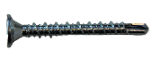 | VitraFix Self Drill ProcellaPro WT fixing | VFSDPP4.838/WT | 4.8x38mm

8.3 FIRE BARRIERS
Product reference:
- Open state horizontal barrier
- Non-ventilated vertical barrier
Fire performance:
- Insulation:
- Integrity:
Manufacturer: Valcan partner manufacturer of fire barriers
Fixings: Fire tested fixings to be advised by Valcan to equivalent performance of fire barrier, fixing reference dictated by substrate.

8.4 BREATHER MEMBRANE
- Product reference: Valcan partner manufacturer Breather Membrane
- Fire performance (BS EN 13501-1): A1 or A2
8.5 INSULATION
- Product reference: Valcan partner manufacturer of insulation
- Thickness: TBC
- Thermal Performance: 0.034 w/mK
- Fire performance (BS EN 13501-1): A1

9. MASONRY FIXINGS (IF REQUIRED)
Masonry / Concrete Fixings:
- ETA-approved, fire-rated fixings
- Pull-out testing to confirm suitability by Valcan partners
10. COORDINATION AND QUALIFICATIONS
- All interfaces with windows, doors, movement joints and adjacent systems to be fully coordinated at detailed design stage.
- Final fixing layouts, bracket spacing and component selection subject to manufacturer’s calculations and approval.
- Installation to be carried out in accordance with manufacturer’s current installation guidance.

TECHNICAL DOWNLOADS
VitraDual Product Brochure April 2026
VitraDual (3mm) BBA Certification
VitraDual (3mm) Efectis Fire Classification Report
VitraDual (2-3mm) Warrington Fire Classification Report
VitraDual Rivet & Cassette CWCT Certification
VitraDual 5754 Grade CCPI Verification Details
VitraDual EPD Certificate
VitraDual Typical Drawings
VitraFix Product Brochure – July 2025
VitraFix Typical Drawings

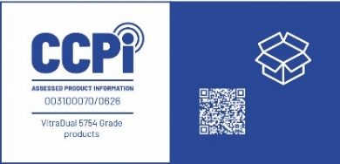

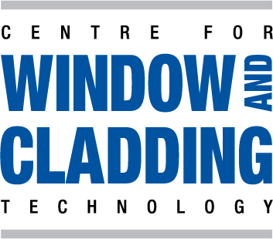
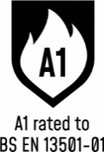

ADDITIONAL RESOURCES & SUPPORT
REGISTER FOR OUR FREE ACCREDITED CPD SEMINARS  Valcan offer free CPD sessions throughout the year which are dedicated to sharing our experiences and helping you to make the correct choices for your building projects.  The CPD program explains the safe cladding solutions available and how to comply with current regulations and illustrates the correct build ups to achieve the government standards. | 
ON-SITE TOOLBOX TALKS  Valcan Toolbox Talks are delivered on site to support safe, compliant installation and reinforce best practice throughout the construction process. These sessions provide clear, practical guidance on system installation, handling, and building safety considerations, helping ensure consistent standards, informed operatives and a strong on‑site safety culture. | 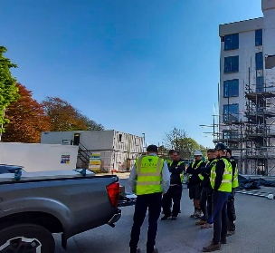
ORDER FREE PRODUCT SAMPLES  Order up to three free samples from our website. See them up close, compare finishes, and find the perfect match for your next project with confidence. We offer colour-matching services for your specific needs. Provide us with the code or a sample and we'll match it while meeting your design requirements. | 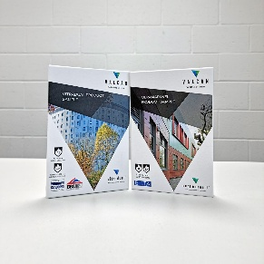
TECHNICAL SERVICES  Valcan offer a wide range of technical services to support project design and system installation. In depth NBS Specifications, project specific CAD drawings, photographic overlays, U-values and condensation / humidity risk analysis documents are all readily available via our website. | 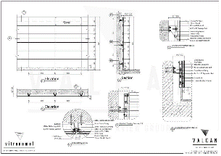
QUALITY, ENVIRONMENTAL AND INFORMATION STANDARDS  Valcan is certified to ISO 9001 and ISO 14001, confirming independently audited quality and environmental management systems that support consistent performance and responsible operations. The organisation is also CCPI Verified, demonstrating a commitment to clear, accurate and transparent construction product information in line with current building safety expectations. |   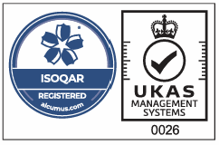

For more information visit www.valcan.co.uk/support/ or contact the team on:
01278 428245 or email enquiries@valcan.co.uk


FAIRVIEW EUROPE T/A VALCAN
Dunball House, Woodlands Court Business Park
Bristol Road, Bridgwater, Somerset TA6 4FJ
Telephone: 01278 428245
Email: enquiries@valcan.co.uk
Web: www.valcan.co.uk

