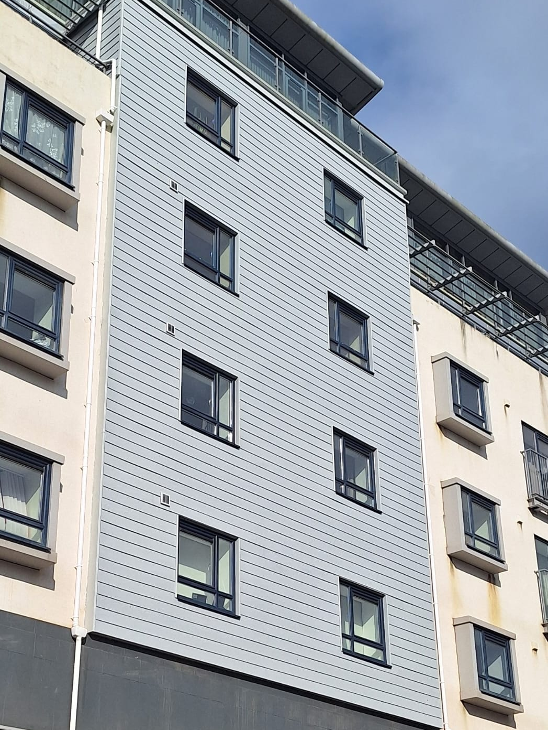



Specifications for NBS Chorus
Evverlap Fibre Cement & VitraFix Overlapping Plank System



SUMMARY
Evverlap boards are factory-manufactured fibre cement plank elements designed for horizontal overlapping installation.
System type: Fibre cement overlapping rainscreen façade system
Fire rating: A2-s1,d0 in accordance with BS EN 13501-1 (subject to full system build-up)
Manufacturer: Valcan with approved partner system components
System type: Overlapping rainscreen façade system
Fixing method: Secret fix (mechanically fixed through upper concealed lap)
Fire rating: A2-s1,d0 classified fibre cement façade system (to BS EN 13501-1)
Warranty: Up to 10 years
Typical applications: Residential, commercial, low- and high-rise façades
Standards: BS 8414-1 / BS 8414-2 tested carrier system, CWCT assessed

CONTENTS
EVVERLAP OVERLAPPING WEATHERBOARD RAINSCREEN SYSTEM | P 4-5
System description
Panel description
Performance
Finish and colour
Application
Specifiers notes – Evverlap | P 6
VITRAFIX ALUMINIUM CARRIER SYSTEM OVERVIEW | P 7-8
System description
Performance and compliance
System options
Application
Specifiers notes | P 8
TYPICAL DRAWINGS | P 9-10
Evverlap Vertical Lapping Plank Section
Everlap Horizontal Lapping Plank Section
TECHNICAL SCHEDULE | P 10 – 14
System summary
Primary cladding details
Panel Fixings and stiffening
Carrier System – Primary Support
Horizontal rails (if required)
Joints and tolerances
Cavity and ventilation
Ancillary components
Masonry fixings (if required)
TECHNICAL DOWNLOADS | P 15
ADDITIONAL RESOURCES | P 16
Contact details | P 17

EVVERLAP OVERLAPPING WEATHERBOARD RAINSCREEN SYSTEM

SYSTEM DESCRIPTON
Evverlap is a non-combustible fibre cement plank rainscreen system designed to replicate the natural appearance of timber cladding while delivering enhanced durability and fire performance.
The system comprises plank-format boards installed horizontally in an overlapping configuration to create a traditional timber aesthetic. The overlapping design provides effective water shedding while concealing fixings for a clean, uninterrupted façade appearance.
Evverlap boards feature a subtle textured finish, including timber-effect options such as teak woodgrain, combining the visual warmth of natural materials with the performance benefits of fibre cement.
PANEL DESCRIPTION
Evverlap planks are factory-manufactured façade elements designed for horizontal overlapping installation.
- Product: Evverlap
- Material: Fibre cement plank system
- Fire classification: A2-s1,d0 to BS EN 13501-1
- Thickness: 8 mm (standard; other thicknesses available on request)
- Weight: ~12 kg/m² (based on 8 mm plank)
- Panel size: 3657 × 210 mm
- Installation: Horizontal overlapping planks (~40 mm overlap)
- Fixing method: Secret-fixed through upper section, concealed by overlapping plank
- Surface: Smooth or textured finish, including timber-effect (e.g. teak woodgrain)
Planks may be supplied in a range of colours and finishes, including timber-effect coatings to replicate natural materials.

PERFORMANCE
Fire performance: A2-s1,d0 classified façade panel in accordance with BS EN 13501-1. Suitable for use within external wall systems designed to meet the requirements of Approved Document B, subject to full system design, substrate and project-specific fire strategy.
Weathering: Overlapping configuration provides effective water shedding and drainage
Durability: High resistance to weathering and environmental exposure
Impact resistance: Suitable for use in residential and commercial applications
Resistance: Highly resistant to rot, insect attack and fungal degradation, unlike traditional timber systems
Maintenance: Low maintenance, with no requirement for re-staining as would be required for natural timber
Installation performance: Lightweight, easy to cut and install using standard tools

FINISH AND COLOUR
Planks are factory finished using durable, high-performance coating systems designed for long-term colour stability and resistance to weathering and pollutants
- Coating: Water-based paint
- Performance: High resistance to UV, weathering and pollutants
- Colour range: Standard and bespoke colours available
Maintenance requirements are minimal, with periodic cleaning recommended. Planks may be overpainted if required to refresh or update the façade appearance
Final finish and colour selection must be confirmed at enquiry stage to align with warranty terms.

APPLICATION
Typical applications include:
- Residential developments
- Commercial buildings
- Mixed-use projects
- Façades requiring a timber-effect aesthetic with non-combustible A2-s1,d0 performance
The system is particularly suited to projects seeking a traditional plank appearance combined with the durability, longevity and low maintenance of fibre cement compared to natural timber

Specifiers notes:
Plank/board Layout:
Planks are installed horizontally with consistent overlap. Layout must be coordinated to suit façade dimensions and detailing.
Fixing Strategy:
Secret-fix system through upper panel zone, concealed by overlapping panel. Fixings to be colour-matched where exposed internally.
Visual Consistency:
Overlap depth and alignment must be maintained consistently across elevations.
Cavity Requirements:
Ventilated cavity to be provided behind planks in accordance with CWCT guidance and fire strategy.

VITRAFIX ALUMINIUM CARRIER SYSTEM OVERVIEW
The following carrier system details describe a typical aluminium support system suitable for non-combustible and A2-s1,d0 classified rainscreen façade systems, illustrated using the VitraFix carrier system.

SYSTEM DESCRIPTION
VitraFix VF1 is an aluminium carrier system comprising brackets, rails and fixings designed to support non-combustible rainscreen façade systems, including A2-s1,d0 classified overlapping weatherboard systems such as Evverlap.
The system provides adjustability, structural support and compatibility with a wide range of substrates.

PERFORMANCE AND COMPLIANCE
Fire performance: Tested to BS 8414-1 and BS 8414-2 as part of an external wall system.
Structural assessment: CWCT tested (subject to project-specific calculations).
Durability: Aluminium components designed for long-term external use.
Warranty: A system warranty is available when specified and installed in accordance with manufacturer’s requirements.

SYSTEM OPTIONS
VitraFix VF1 – Primary Bracket System
VitraFix VF1 is an adjustable aluminium bracket system designed to accommodate variations in substrate tolerance and cavity depth.
- Adjustability: 102–235 mm
- Application: Direct bracket fixing to structural substrate
- Extensions: Additional depth may be achieved by incorporating the VitraFix VF2 system components.
- Options: Custom bracket depths are available subject to project requirements.
VF1 is typically used as the primary carrier system for mechanically fixed rainscreen façade systems, including overlapping weatherboard systems.

VitraFix VF2 – Rail and Secondary Support System
VitraFix VF2 comprises aluminium or steel top-hats and C-channel rails designed to provide additional system depth or allow brackets to be installed independently of stud locations.
- Enables alignment of the carrier system where stud positions are restrictive
- Can be used to increase overall system build-up depth
- Top-hats may be used independently as an alternative to timber batten sub-grids
VF2 components may be used in conjunction with VF1 brackets or as part of a secondary support arrangement, subject to design requirements.

APPLICATION
The VitraFix carrier system is suitable for use with non-combustible and A2-s1,d0 classified façade systems on residential, commercial and mixed-use buildings. Final system selection, bracket spacing and fixing strategy shall be determined by project-specific structural and wind load calculations.

Specifier’s Notes:
Bracket type, spacing and material selection to be confirmed based on substrate, cavity depth and wind load calculations.
Movement joints and tolerance allowances to be incorporated in façade design to accommodate thermal expansion, substrate movement and building deflection.

TYPICAL DETAILS
Details shown are indicative only and shall be developed to suit project‑specific geometry, substrate and fire strategy.
EVVERLAP VERTICAL LAPPING PLANK SECTION

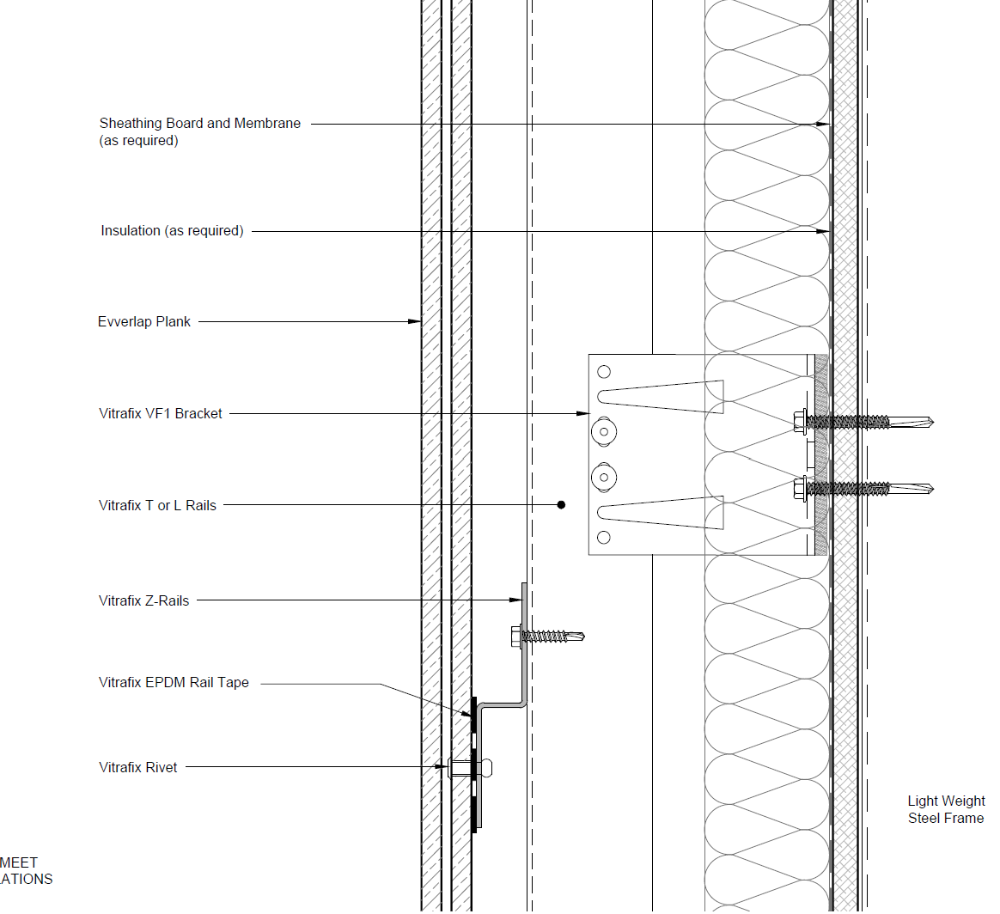

EVVERLAP HORIZONTAL LAPPING PLANK SECTION

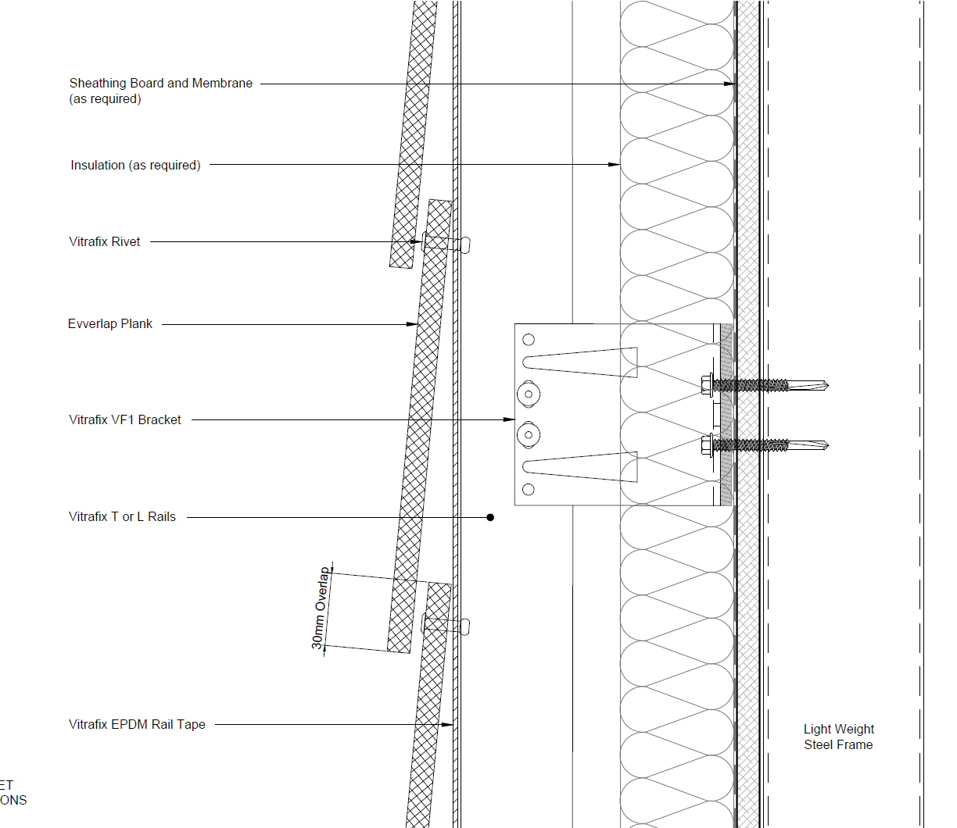

All Technical Details can be found at https://valcan.co.uk/wp-content/uploads/2025/07/EVVERLAP-TECHNICAL-DRAWINGS.zip or on request.

TECHNICAL SCHEDULE
Purpose of this schedule
This Technical Schedule provides detailed system components and reference information to support detailed design, coordination and installation.
Final configuration, sizing and fixing arrangements shall be confirmed by project-specific calculations and manufacturer approval.
1. SYSTEM SUMMARY
- Façade system: Evverlap Plank System
- System type: Overlapping façade rainscreen system
- Carrier system: VitraFix VF1 (VF2 where required)
- Fire classification (system intent): A2-s1,d0 in accordance with BS EN 13501-1

Standards: BS EN 13501-1, CWCT, BS 8414 (Informational summary only – see sections below for component detail)

2. PRIMARY CLADDING DETAILS
Product reference: Evverlap Overlapping Plank System
Manufacturer: Fairview Europe t/a Valcan
Product name: Evverlap
Material: Fibre Cement
Thickness and Weight:
- Thickness: 8 mm (standard; other thicknesses available on request)
- Weight (kg/m²): ~12 kg/m²
Panel Dimensions:
- 3657 × 210 mm
- Installed horizontally
Fire Performance:
- A2-s1,d0 to BS EN 13501-1

3. PANEL FIXING
Fixing method: Secret-fixed via upper panel section, concealed by overlapping course.
Fixing rules:
- Fixing centres subject to project design
- Installed through upper lap prior to next panel installation
3.1 PRIMARY PANEL FIXINGS
 | Rail/fixing type | Reference | Sizes
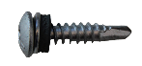 | VitraFix Self Drill Panhead A4, colour matched to panel | VFSDP5.535C | 5.5x35mm (200 box)

4. CARRIER SYSTEM
Carrier system reference: VitraFix VF1
- Manufacturer: Fairview Europe t/a Valcan
Material: Aluminium
System Description: Brief description of role within façade build-up
 | Bracket Reference | Size | Adjustment Range
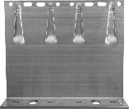 | VF140DB | 65 mm-260 mm double bracket | 142–172 mm
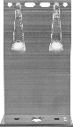 | VF140SB | 65mm-260 mm single bracket | 142–172mm
4.1 BRACKETS
Bracket selection and spacing subject to structural and wind load calculations.
4.2 RAILS
 | Rail type | Reference | Sizes
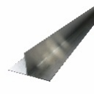 | T-Rail | VFTR503 / VFTR506 | 50 x 100 x 3000 mm / 50 x 100 x 6000 mm
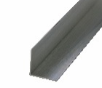 | L-Rail | VFLR503 / VFLR506 | 50 x 50 x 3000 mm /  50 x 50 x 6000 mm

5. HORIZONTAL RAILS (IF APPLICABLE)
System reference: VitraFix VF2
- Used for SFS coordination or increased depth
- Not typically required for masonry
5.1 RAILS AND FIXINGS
 | Rail/fixing type | Reference | Sizes
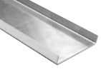 | U-Rail | VF2/U | 90x15x2mm / 174x15x2mm
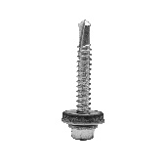 | VitraFix Self Drill Hex head with washer | VFSD.538/A4 | 5.5x38mm
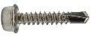 | VitraFix Self Drill Hex head | VFSD4.825 (See manufacturers details for fixing centres) | 4.8x25mm, 8mm

6. JOINTS AND TOLERANCES
Joint type: Closed joint
Configuration: Overlapping weatherboard
No visible vertical panel joints
7. CAVITY AND VENTILATION
Cavity Depth:
- 25 mm (closed joint system)
- 50 mm where open ventilation required
Measured from insulation to rear of panel

8. ANCILLARY COMPONENTS
8.1 SHEATHING BOARDS
- Product reference: ProcellaPro
- Panel size: 2500 x 1250mm
- Thickness/weight: 12 mm / 21.6 kg/m²
- Fire Rating to BS EN 13501-1: A1
- Manufacturer: Fairview Europe t/a Valcan

8.2 FIXINGS
 | Rail/fixing type | Reference | Sizes
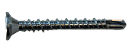 | VitraFix Self Drill ProcellaPro WT fixing | VFSDPP4.838/WT | 4.8x38mm

8.3 FIRE BARRIERS
Product reference:
- Open state horizontal barrier
- Non-ventilated vertical barrier
Fire performance:
- Insulation:
- Integrity:
Manufacturer: Valcan partner manufacturer of fire barriers
Fixings: Fire tested fixings to be advised by Valcan to equivalent performance of fire barrier, fixing reference dictated by substrate.
8.4 BREATHER MEMBRANE
- Product reference: Valcan partner manufacturer Breather Membrane
- Fire performance (BS EN 13501-1): A1 or A2

8.5 INSULATION
- Product reference: Valcan partner manufacturer of insulation
- Thickness: TBC
- Thermal Performance: 0.034 w/mK
- Fire performance (BS EN 13501-1): A1

9. MASONRY FIXINGS (IF REQUIRED)
Masonry / Concrete Fixings:
- ETA-approved, fire-rated fixings
- Pull-out testing to confirm suitability by Valcan partners
10. COORDINATION AND QUALIFICATIONS
- All interfaces with windows, doors, movement joints and adjacent systems to be fully coordinated at detailed design stage.
- Final fixing layouts, bracket spacing and component selection subject to manufacturer’s calculations and approval.
- Installation to be carried out in accordance with manufacturer’s current installation guidance.

TECHNICAL DOWNLOADS
Evverlap Product Brochure – July 2025
Evverlap Typical Drawings
Evverlap A2 Classification Fire Report
Evverlap Declaration of Performance (DoP)

ADDITIONAL RESOURCES & SUPPORT
REGISTER FOR OUR FREE ACCREDITED CPD SEMINARS  Valcan offer free CPD sessions throughout the year which are dedicated to sharing our experiences and helping you to make the correct choices for your building projects.  The CPD program explains the safe cladding solutions available and how to comply with current regulations and illustrates the correct build ups to achieve the government standards. | 
ON-SITE TOOLBOX TALKS  Valcan Toolbox Talks are delivered on site to support safe, compliant installation and reinforce best practice throughout the construction process. These sessions provide clear, practical guidance on system installation, handling, and building safety considerations, helping ensure consistent standards, informed operatives and a strong on‑site safety culture. | 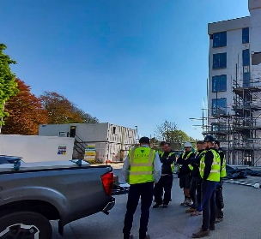
ORDER FREE PRODUCT SAMPLES  Order up to three free samples from our website. See them up close, compare finishes, and find the perfect match for your next project with confidence. We offer colour-matching services for your specific needs. Provide us with the code or a sample and we'll match it while meeting your design requirements. | 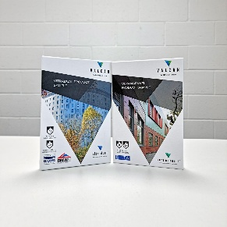
TECHNICAL SERVICES  Valcan offer a wide range of technical services to support project design and system installation. In depth NBS Specifications, project specific CAD drawings, photographic overlays, U-values and condensation / humidity risk analysis documents are all readily available via our website. | 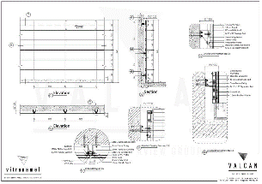
QUALITY, ENVIRONMENTAL AND INFORMATION STANDARDS  Valcan is certified to ISO 9001 and ISO 14001, confirming independently audited quality and environmental management systems that support consistent performance and responsible operations. The organisation is also CCPI Verified, demonstrating a commitment to clear, accurate and transparent construction product information in line with current building safety expectations. |   

For more information visit www.valcan.co.uk/support/ or contact the team on:
01278 428245 or email enquiries@valcan.co.uk

CONTACTS
Façade Consultant – {Insert Name}
Telephone – {Insert direct number & mobile}
Email – {insertname}@valcan.co.uk

FAIRVIEW EUROPE T/A VALCAN
Dunball House, Woodlands Court Business Park
Bristol Road, Bridgwater, Somerset TA6 4FJ
Telephone: 01278 428245
Email: enquiries@valcan.co.uk
Web: www.valcan.co.uk



