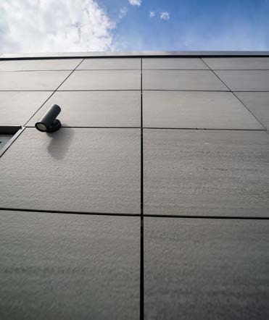

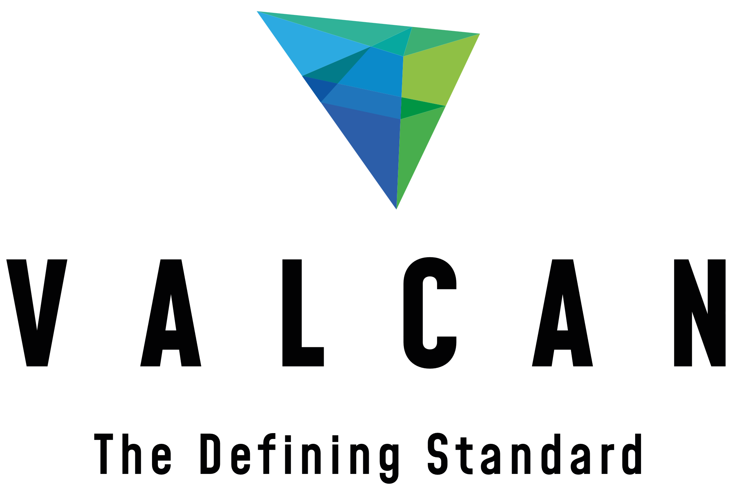

Specifications for NBS Chorus
Frontek Secret-Fix & VitraFix (VF1/VF2) System



SUMMARY
System name: Frontek Secret-Fix Rainscreen System (VF1)
System basis of design: Frontek extruded porcelain façade panels designed for secret-fix installation and supported on the Vitrafix VF1 aluminium carrier subframe system, incorporating either the VFI+ hook-on clip system or VFI Super+ horizontal carrier system.
Manufacturer:
- Cladding panels: Frontek (Greco Gres Internacional)
- Carrier system: Valcan (Vitrafix VF1) with approved partner system components
System type: A1 non-combustible extruded porcelain rainscreen façade system with concealed mechanical fixings
Fixing method:
Secret-fixed rainscreen system using one of the following:
- VFI+ System:
Hook-on clip fixing method, whereby proprietary clips are mechanically fixed to the Vitrafix VF1 vertical rails, allowing panels to be installed by engagement from above.
- VFI Super+ System:
Horizontal carrier system fixed back to Vitrafix VF1 vertical rails, allowing panels to be installed independently of the backing structure and enabling staggered vertical joint layouts.
Fire rating: A1 non-combustible throughout (panels, carrier system, insulation and ancillary components subject to specification)
Warranty: System warranty available (typically up to 25 years), subject to full system specification, approved components and compliant installation
Standards:
- Designed in accordance with CWCT guidance
- System components tested to BS 8414 (system dependent)
- Fire classification to BS EN 13501-1 (A1)
- NBS specification compatible

CONTENTS
FRONTEK A1 PORCELAIN RAINSCREEN CLADDING SYSTEM | P 4-6
System description
Panel description
Performance
Finish and colour
Application
Specifiers notes – Frontek | P 7
VITRAFIX ALUMINIUM CARRIER SYSTEM OVERVIEW | P 8-10
System description
Performance and compliance
System options
Application
Specifiers notes - VitraFix | P 10
TYPICAL DRAWINGS | P 11
VFI+ hook-on clip system
VFI Super+ horizontal carrier system

TECHNICAL SCHEDULE | P 12 – 17
System summary
Primary cladding details
Panel Fixings and stiffening
Carrier System – Primary Support
Horizontal rails (if required)
Joints and tolerances
Cavity and ventilation
Ancillary components
Masonry fixings (if required)
TECHNICAL DOWNLOADS | P 18
ADDITIONAL RESOURCES | P 19
Contact details | P 20

FRONTEK A1 PORCELAIN RAINSCREEN CLADDING SYSTEM
SYSTEM DESCRIPTON
The Frontek system is a non-combustible extruded porcelain rainscreen façade system, designed for installation as a ventilated cladding solution with concealed mechanical fixings.
The system comprises Frontek porcelain panels mechanically fixed to an aluminium support structure, using the Vitrafix VF1 carrier system with secret-fix installation methodologies.
Two principal fixing configurations are available:
- VFI+ hook-on clip system, and
- VFI Super+ horizontal carrier system
Both systems provide a fully drained and ventilated façade, improving thermal and acoustic performance while delivering a durable, low-maintenance external envelope.
The system is suitable for both new-build and refurbishment applications and is designed to meet current UK building regulations for high-rise and non-combustible façade construction.

PANEL DESCRIPTION
Frontek panels are manufactured from extruded vitrified porcelain, formed with a proprietary honeycomb internal structure which provides a combination of high strength and reduced weight.
Panels incorporate longitudinal grooves along their edges, allowing them to be mechanically secured using concealed fixing systems without the need for face fixing or drilling.
Typical characteristics:
- Material: Extruded vitrified porcelain
- Structure: Alveolar (honeycomb) profile
- Weight: Approx. 32 kg/m²
- Sizes: Standard formats 405 × 800 mm and 405 × 1000 mm, with large format panels available up to 1000 × 3000 mm
Panels are precision manufactured to tight tolerances and can be cut or adapted to accommodate project-specific façade geometries.

PERFORMANCE
The Frontek system provides a high-performance façade solution with proven durability and compliance with modern construction standards.
Fire performance:
- Classification: A1 non-combustible to BS EN 13501-1
Physical and durability performance:
- Water absorption: ≤ 0.5%
- High resistance to frost, UV exposure, and environmental pollutants
- High mechanical strength and impact resistance
- Excellent long-term colour stability
System benefits:
- Ventilated façade construction improves thermal efficiency and reduces condensation risk
- Acoustic performance improved through air cavity and dense panel construction
- Resistant to corrosion, chemical attack and marine environments
Final system performance is subject to project-specific structural calculations, substrate condition, and fixing design in accordance with CWCT guidelines.

FINISH AND COLOUR
Frontek panels are available in a wide range of finishes and colours, enabling flexibility in architectural design.
Available finish types include:
- Stone and natural textures
- Timber-effect finishes
- Metallic finishes
- Smooth and contemporary surfaces
Panels are manufactured with through-body colour, providing excellent resistance to fading and ensuring long-term aesthetic durability without coating degradation.
Custom colours and formats may be available subject to project requirements.

APPLICATION
The Frontek rainscreen system is suitable for use on external façades across a wide range of building types, including:
- High-rise residential buildings
- Commercial offices
- Education and healthcare buildings
- Mixed-use developments
- Façade remediation and recladding projects
The system is particularly suitable for projects requiring:
- A1 non-combustible façade materials
- Durable, low-maintenance cladding solutions
- Architecturally versatile façade finishes
PANEL FIXING METHOD – SECRET FIX SYSTEMS
VFI+ HOOK-ON SYSTEM
Panels are fixed using a proprietary hook-on clip system, where mechanical clips are engaged with the horizontal grooves formed within the panel edges.
- Clips are fixed directly to Vitrafix VF1 vertical aluminium rails
- Panels are installed by lowering into position from above
- Provides a fully concealed fixing solution
- Typically results in a stack bond façade layout
Key benefits:
- Fast installation
- Demountability and panel replacement
- Clean, uniform joint lines
VFI SUPER+ SYSTEM
Panels are supported on horizontal carrier rails fixed back to the Vitrafix VF1 vertical rails.
- Horizontal channels provide panel support and alignment
- Panels can be installed independently of the backing structure (SFS studs)
- Enables staggered vertical joint layouts and more complex façade designs
Key benefits:
- Increased design flexibility
- Improved installation sequencing
- Greater tolerance accommodation across the façade

Specifiers notes:
General:
Specifier to confirm system configuration (VFI+ or VFI Super+), panel dimensions, layout and fixing methodology in coordination with the system manufacturer to suit project-specific performance requirements.
Fire Performance:
Frontek panels are classified as A1 non-combustible. The full façade build-up, including insulation, cavity barriers and membranes, must be specified to ensure compliance with Approved Document B and the project fire strategy.
Panel Layout and Size:
Panel dimensions, joint widths and layout (stack bond or staggered) are subject to structural performance, wind loading and aesthetic requirements. Final arrangement to be confirmed through detailed design.
Structural Design and Wind Loading:
Bracket spacing, rail configuration and fixing centres shall be determined based on project-specific wind load calculations in accordance with CWCT guidance.
Cavity and Ventilation:
Minimum cavity depth shall be maintained to allow effective ventilation and drainage. Cavity reductions at fire barriers or interfaces must be carefully coordinated.
Thermal Performance:
Thermal isolators may be required at bracket locations to minimise cold bridging and achieve project U-value targets.
Installation:
Installation must be carried out by a competent specialist contractor in accordance with manufacturer’s current installation guidance.
Appearance and Finish:
Final finish and colour selection to be confirmed by the Architect. Variations in tone and texture are inherent to ceramic materials and should be considered during sample approval.
Coordination:
All interfaces with windows, soffits, movement joints and adjacent façade elements must be fully coordinated to ensure continuity of fire performance, weather resistance and visual alignment.

VITRAFIX ALUMINIUM CARRIER SYSTEM OVERVIEW

SYSTEM DESCRIPTION
VitraFix is an adjustable aluminium carrier system designed to support non-combustible rainscreen cladding systems, including Frontek extruded porcelain panels.
The system comprises a combination of brackets, vertical rails, horizontal carriers (where applicable), and mechanical fixings, forming a robust subframe that transfers loads safely to the primary structure.
When used with Frontek, the VitraFix VF1 system provides a stable and fully adjustable support structure for the integration of secret-fix cladding systems, including both VFI+ hook-on clip installations and VFI Super+ horizontal carrier systems.
The system accommodates building tolerances, thermal movement and structural deflection, while maintaining accurate panel alignment and consistent façade geometry.

PERFORMANCE AND COMPLIANCE
Fire performance:
- Suitable for use in A1 non-combustible façade systems when combined with compliant cladding, insulation and ancillary components
- System assemblies may be designed in line with BS 8414 tested façade constructions (subject to full build-up specification)
Structural performance:
- Designed in accordance with CWCT guidance for rainscreen cladding systems
- Loadings including wind pressure, dead load and imposed loads shall be calculated on a project-specific basis
Durability:
- Aluminium components designed for long-term external exposure
- Corrosion resistant and suitable for a range of environmental conditions
Adjustability: Bracket system allows for varying stand-off distances to accommodate substrate irregularities and cavity requirements
Warranty: System warranty available where the full façade system is supplied, specified and installed in accordance with manufacturer’s requirements

SYSTEM OPTIONS
VITRAFIX VF1 – PRIMARY BRACKET SYSTEM
VitraFix VF1 is the primary aluminium bracket and rail system used to support Frontek cladding panels.
- Configuration: Adjustable brackets fixed back to structural substrate, supporting vertical aluminium rails
- Application: Suitable for masonry, concrete or SFS backing structures
- Adjustment range: Typically 100–235 mm (subject to bracket type)
- Function: Provides primary support and alignment framework for cladding system
VF1 vertical rails act as the main interface for panel fixing systems, including direct clip engagement (VFI+) or secondary horizontal rails (VFI Super+).

VFI+ SYSTEM (VERTICAL RAIL – HOOK-ON CLIP)
The VFI+ system utilises the VF1 vertical rail arrangement as the primary fixing interface.
- Proprietary clips are mechanically fixed to the VF1 vertical rails
- Frontek panels engage directly onto clips via their profiled edges
- Panels are installed vertically by lowering into position
System characteristics:
- Fully secret-fixed façade system
- Direct engagement with vertical support rails
- Typically used where uniform, stacked panel layouts are required

VFI SUPER+ SYSTEM (HORIZONTAL CARRIER)
The VFI Super+ system incorporates horizontal carrier rails fixed to the VF1 vertical rails.
- Horizontal channels provide intermediate support to Frontek panels
- Panels are fixed independently of vertical stud positions
- Allows increased flexibility in panel layout and sequencing
System characteristics:
- Enables staggered vertical joints and varied panel arrangements
- Provides greater installation flexibility, particularly over SFS systems
- Improves tolerance management across the façade

APPLICATION
The VitraFix carrier system is suitable for use with Frontek porcelain rainscreen cladding systems on:
- High-rise residential developments
- Commercial office buildings
- Education and healthcare facilities
- Mixed-use and refurbishment projects
The system is compatible with a range of substrates and can be adapted to suit varying façade geometries, cavity depths and project requirements.

Specifier’s Notes:
General: Specifier to confirm carrier system configuration (VF1 with VFI+ or VFI Super+) in conjunction with the selected Frontek panel layout and project-specific requirements.
Bracket Selection: Bracket type, size and spacing shall be determined based on substrate condition, cavity depth, and calculated wind loads.
Rail Configuration: Vertical rail spacing and section size shall be designed to accommodate panel size, fixing system and structural requirements. Where VFI Super+ is employed, horizontal carrier rails shall be included as part of the system design.
Structural Design: All components of the VitraFix carrier system shall be designed and installed in accordance with project-specific structural calculations and CWCT guidance.
Thermal Bridging: Thermal isolation pads or breaks should be incorporated at bracket positions where required to achieve project thermal performance targets.
Fire Compliance: The complete wall build-up, including cladding, carrier system, insulation and cavity barriers, must be coordinated to meet the requirements of Approved Document B and the project fire strategy.
Cavity Depth: Minimum cavity depth shall be maintained to ensure adequate drainage and ventilation. Localised reductions may occur at fire barrier positions and must be coordinated during detailed design.
Installation: Installation shall be carried out by a competent specialist contractor in accordance with the manufacturer’s current guidance and project-specific drawings.
Coordination: The carrier system shall be fully coordinated with window interfaces, movement joints, fire barriers and adjacent façade elements to ensure continuity of performance and finish.

TYPICAL DETAILS
Details shown are indicative only and shall be developed to suit project‑specific geometry, substrate and fire strategy.
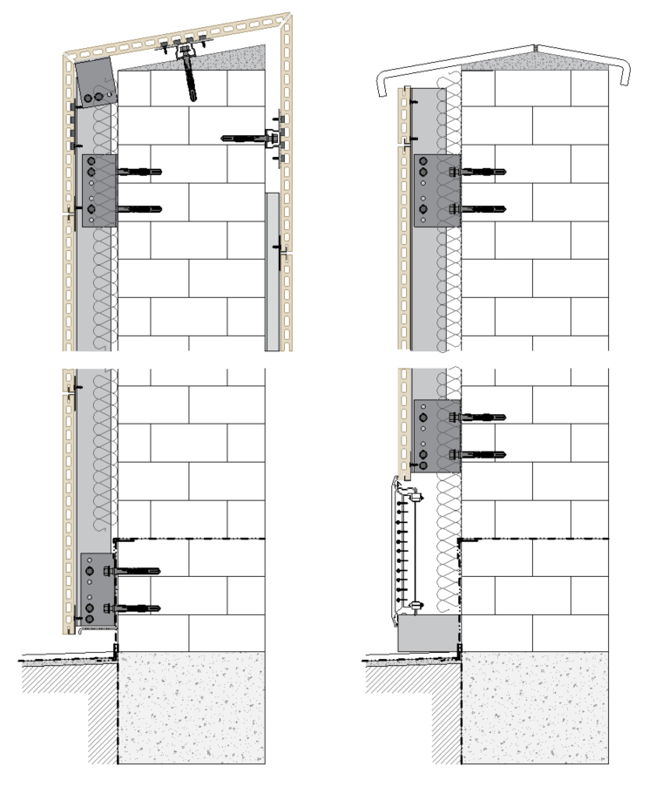
All Technical Details can be found at Frontek Extruded Porcelain Facade Cladding Panels | Valcan or on request.

TECHNICAL SCHEDULE
Purpose of this schedule
This Technical Schedule provides detailed system components and reference information to support design, coordination and installation of the Frontek porcelain rainscreen façade system.
Final configuration, fixing centres and component selection shall be confirmed via project-specific structural calculations and manufacturer approval.
1. SYSTEM SUMMARY
Façade system name: Frontek Secret-Fix Rainscreen System
System type: Extruded porcelain rainscreen façade system (secret-fixed)
Primary carrier system: VitraFix VF1 (with secondary rails where required)
Fixing systems:
- VFI+ Hook-on Clip System
- VFI Super+ Horizontal Carrier System
Fire classification (system intent): A1 non-combustible [source.thenbs.com]
Applicable standards: CWCT guidance, BS EN 13501-1
2. PRIMARY CLADDING DETAILS
Product reference: Frontek Porcelain Façade Panel
Manufacturer: Greco Gres Internacional
Material: Extruded vitrified porcelain
Panel structure: Honeycomb (alveolar) profile
Thickness and Weight
Thickness: Approx. 18–20 mm
Weight: ~32 kg/m²
Panel Dimensions
Standard sizes: 405 × 800 mm / 405 × 1000 mm
Large format: Up to 1000 × 3000 mm (subject to design)
Fire Performance Classification: A1 to BS EN 13501-1

3. PANEL FIXING AND SUPPORT
3.1 PRIMARY PANEL FIXING – VFI+ (HOOK-ON)
Component | Description | Reference | Notes
Hook-on Clip | Proprietary mechanical clip | VFI+ Clip System | Engages into panel grooves
Fixing screw | Stainless steel self-drill fixing | A4 grade | Fixes clips to VF1 rails

Fixing method: Panels are installed by lowering onto clips fixed to VF1 vertical rails, providing concealed fixing and demountability.

3.2 PANEL FIXING – VFI SUPER+ (HORIZONTAL CARRIER)
Component | Description | Reference | Notes
Horizontal carrier rail | Aluminium support rail | VFI Super+ Rail | Fixed to VF1 vertical rails
Panel engagement system | Mechanical support system | Integrated fixing | Supports panel independently of SFS

Fixing method: Panels fixed onto horizontal carriers, allowing staggered joints and independent installation sequencing.

3.3 PANEL EDGE GEOMETRY
- Integrated longitudinal grooves for mechanical fixing
- No face fixings required
- Designed for concealed fixing engagement

4. CARRIER SYSTEM – PRIMARY SUPPORT
Carrier system reference: VitraFix VF1
Manufacturer: Valcan (Fairview Europe)
Material: Aluminium
 | Bracket Reference | Size | Adjustment Range
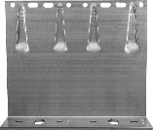 | VF1-DB | 65–260 mm double bracket | ~100–235 mm
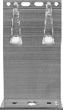 | VF1-SB | 65–260 mm single bracket | ~100–235 mm
4.1 BRACKETS
Bracket selection and spacing subject to structural and wind load calculations.
- Adjustable to suit cavity depth and tolerances
- Fixed to structural substrate (concrete / masonry / SFS)
4.2 THERMAL/ISOLATION PADS
 | Bracket Reference | Size | Adjustment Range
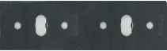 | VFIP-SB | Double bracket thermal pad | 3 mm
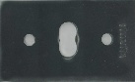 | VFIP-DB | Single bracket thermal pad | 3mm

4.3 VERTICAL RAILS
 | Rail type | Reference | Sizes
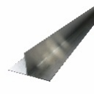 | T-Rail | VFTR503 / VFTR506 | 50 x 100 x 3000 mm / 50 x 100 x 6000 mm
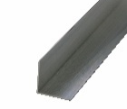 | L-Rail | VFLR503 / VFLR506 | 50 x 50 x 3000 mm /  50 x 50 x 6000 mm

5. HORIZONTAL RAILS (VFI SUPER+ ONLY)
System reference: VFI Super+ Horizontal Carrier
Function: Provides panel support independent of substrate/studs
5.1 RAILS AND FIXINGS
 | Rail/fixing type | Reference | Sizes
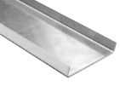 | U-Rail | VF2/U | 90x15x2mm / 174x15x2mm
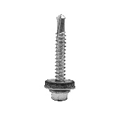 | VitraFix Self Drill Hex head with washer | VFSD.538/A4 | 5.5x38mm
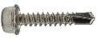 | VitraFix Self Drill Hex head | VFSD4.825 (See manufacturers details for fixing centres) | 4.8x25mm, 8mm
 | Masonry anchors - ETA approved fire-rated fixing | Valcan partner approved fixings

6. JOINTS AND TOLERANCES
Joint type: Open joint (ventilated façade)
Joint width: Typically 8–12 mm (project specific)
Layout options:
- Stack bond (VFI+)
- Staggered bond (VFI Super+)
Joints to accommodate:
- Thermal expansion
- Structural movement
- Installation tolerances

7. CAVITY AND VENTILATION
Cavity Depth
- Minimum 25 mm (recommend 25–50 mm typical)
Ventilation Strategy
- Open, drained and ventilated cavity
- Continuous airflow maintained
- Compliant with CWCT guidance
- Cavity may be reduced locally at fire barriers in coordination with system design

8. ANCILLARY COMPONENTS
Ancillary panel fixings listed are for rear-of-panel fabrication only and do not represent face-fixed or rivet-fixed cassette installation.
8.1 SHEATHING BOARDS
- Product reference: ProcellaPro
- Panel size: 2500 x 1250mm
- Thickness/weight: 12 mm / 21.6 kg/m²
- Fire Rating to BS EN 13501-1: A1
- Manufacturer: Fairview Europe t/a Valcan
8.2 FIXINGS
 | Rail/fixing type | Reference | Sizes
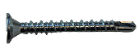 | VitraFix Self Drill ProcellaPro WT fixing | VFSDPP4.838/WT | 4.8x38mm

8.3 FIRE BARRIERS
- Horizontal open-state cavity barriers
- Vertical non-ventilated fire barriers
- Installed in accordance with fire strategy
Manufacturer: Valcan partner manufacturer of fire barriers
Fixings: Fire tested fixings to be advised by Valcan to equivalent performance of fire barrier, fixing reference dictated by substrate.

8.4 BREATHER MEMBRANE
- Product reference: Valcan partner manufacturer Breather Membrane
- Fire classification: A2-s1,d0 minimum (or A1 where specified)
- Installed behind carrier system

8.5 INSULATION
- Product reference: Valcan partner manufacturer of insulation
- Thickness: TBC
- Thermal Performance: 0.034 w/mK
- Fire performance (BS EN 13501-1): A1

9. MASONRY FIXINGS (IF REQUIRED)
Masonry / Concrete Fixings:
- ETA-approved, fire-rated fixings
- Pull-out testing to confirm suitability by Valcan partners

10. COORDINATION AND QUALIFICATIONS
All interfaces with:
- Windows
- Doors
- Movement joints
- Adjacent façade systems
to be fully coordinated at design stage
Final fixation layout, bracket spacing and system design:
- Subject to structural calculations
- Approved by system manufacturer
Installation to be carried out by experienced façade contractor in accordance with manufacturer guidance

TECHNICAL DOWNLOADS
Frontek Fire Safety Certification
Frontek Fire Classification Report
Frontek Technical Drawings – Horizontal
Frontek Technical Drawings – Vertical
Frontek Environmental Product Declaration
VitraFix Product Brochure – July 2025
VitraFix Typical Drawings


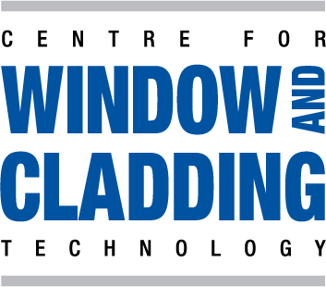
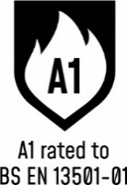

ADDITIONAL RESOURCES & SUPPORT
REGISTER FOR OUR FREE ACCREDITED CPD SEMINARS  Valcan offer free CPD sessions throughout the year which are dedicated to sharing our experiences and helping you to make the correct choices for your building projects.  The CPD program explains the safe cladding solutions available and how to comply with current regulations and illustrates the correct build ups to achieve the government standards. | 
ON-SITE TOOLBOX TALKS  Valcan Toolbox Talks are delivered on site to support safe, compliant installation and reinforce best practice throughout the construction process. These sessions provide clear, practical guidance on system installation, handling, and building safety considerations, helping ensure consistent standards, informed operatives and a strong on‑site safety culture. | 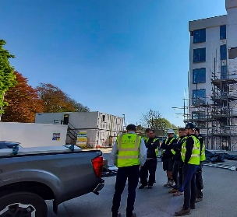
ORDER FREE PRODUCT SAMPLES  Order up to three free samples from our website. See them up close, compare finishes, and find the perfect match for your next project with confidence. We offer colour-matching services for your specific needs. Provide us with the code or a sample and we'll match it while meeting your design requirements. | 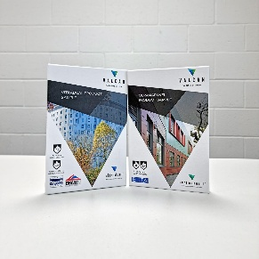
TECHNICAL SERVICES  Valcan offer a wide range of technical services to support project design and system installation. In depth NBS Specifications, project specific CAD drawings, photographic overlays, U-values and condensation / humidity risk analysis documents are all readily available via our website. | 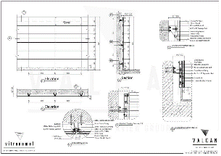
QUALITY, ENVIRONMENTAL AND INFORMATION STANDARDS  Valcan is certified to ISO 9001 and ISO 14001, confirming independently audited quality and environmental management systems that support consistent performance and responsible operations. The organisation is also CCPI Verified, demonstrating a commitment to clear, accurate and transparent construction product information in line with current building safety expectations. |   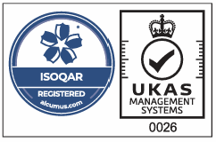

For more information visit www.valcan.co.uk/support/ or contact the team on:
01278 428245 or email enquiries@valcan.co.uk

FAIRVIEW EUROPE T/A VALCAN
Dunball House, Woodlands Court Business Park
Bristol Road, Bridgwater, Somerset TA6 4FJ
Telephone: 01278 428245
Email: enquiries@valcan.co.uk
Web: www.valcan.co.uk



