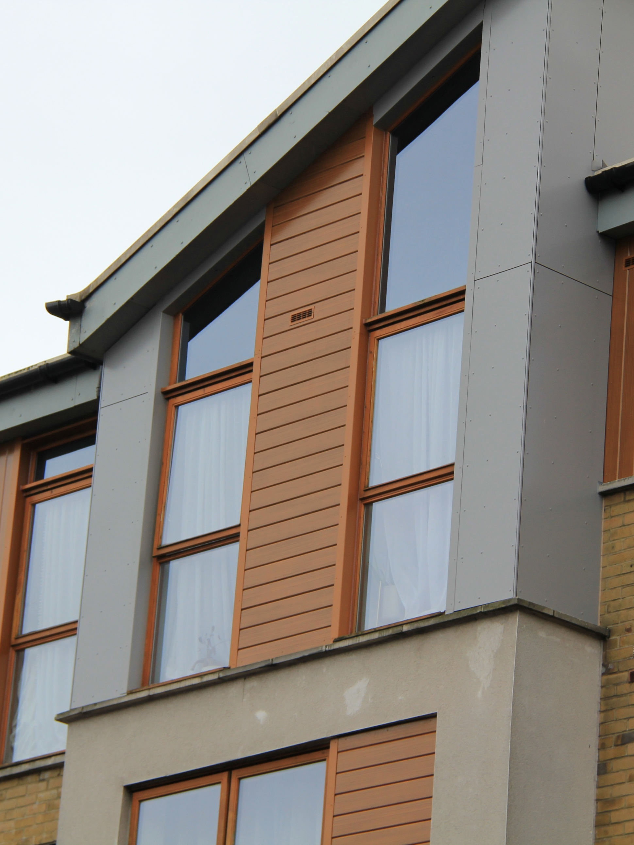



Specifications for NBS Chorus
VitraDual & VitraFix (VF1/VF2) Interlocking Plank System



SUMMARY
System name: VitraDual Interlocking Plank Rainscreen System
System basis of design: VitraDual A1 aluminium interlocking plank panels installed onto the VitraFix aluminium carrier system. The interlocking plank design provides a concealed-fix, plank-style façade aesthetic with a durable, non-combustible aluminium construction.
Manufacturer: Valcan with approved partner system components
System type: A1 aluminium interlocking plank rainscreen façade system.
Fixing method: Interlocking plank system with concealed mechanical fixings and rear stiffened panels installed onto an aluminium carrier system.
Fire rating: A1 throughout (panels, carrier system, insulation and breather membrane), classified to BS EN 13501-1. Suitable for use on buildings subject to ADB v2 requirements.
Warranty: Up to 30 years
Typical applications: Residential, commercial and mixed-use developments, including high-rise buildings where a modern plank-effect façade and non-combustible construction are required.
Standards: BS 8414 tested, CWCT, BBA certified*

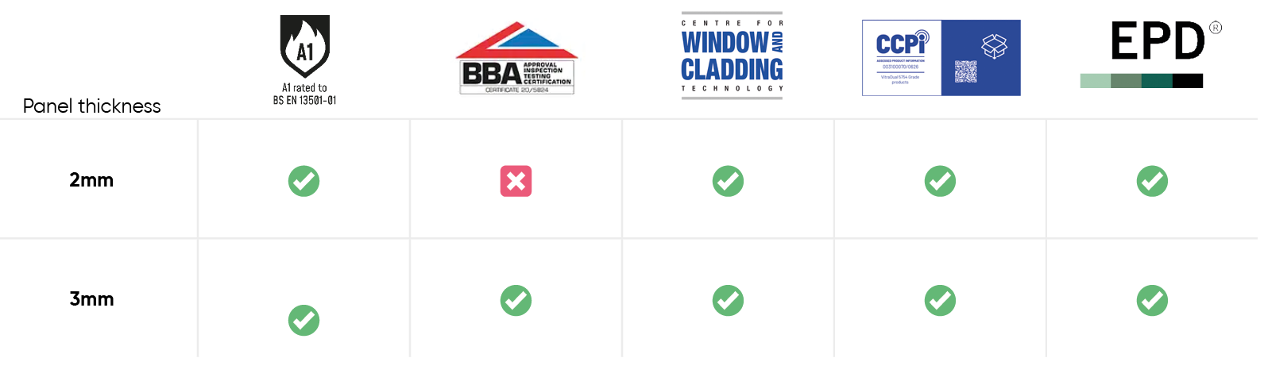

* Vitradual 3mm is manufactured by Valcan and is available with BBA certification when produced at BBA-certified production facilities. Certification requirements must be specified at enquiry and order stage. Contact us for more details

CONTENTS
VITRADUAL A1 ALUMINIUM INTERLOCKING PLANK RAINSCREEN SYSTEM | P 4-6
System description
Panel description
Performance
Finish and colour
Application
Specifiers notes – VitraDual | P 7
VITRAFIX ALUMINIUM CARRIER SYSTEM OVERVIEW | P 7-9
System description
Performance and compliance
System options
Application
Specifiers notes - VitraFix | P 10
TYPICAL DRAWINGS | P 11-12
Interlocking plank system typical detail coping
Interlocking plank system typical detail window head
Interlocking plank system typical detail external corner
Interlocking plank system typical detail internal corner
TECHNICAL SCHEDULE | P 13 – 18
System summary
Primary cladding details
Panel Fixings and stiffening
Carrier System – Primary Support
Horizontal rails (if required)
Joints and tolerances
Cavity and ventilation
Ancillary components
Masonry fixings (if required)
TECHNICAL DOWNLOADS | P 19
ADDITIONAL RESOURCES | P 20
Contact details | P 21

VITRADUAL A1 ALUMINIUM INTERLOCKING PLANK RAINSCREEN SYSTEM
SYSTEM DESCRIPTON
The VitraDual Interlocking Plank Rainscreen System is a non-combustible A1-rated aluminium façade system formed using profiled interlocking plank panels installed onto an aluminium carrier system. The system provides a concealed-fix plank-effect façade, combining the linear appearance of timber cladding with the durability and fire performance of solid aluminium.
VitraDual interlocking planks are manufactured from solid aluminium sheet and precision-formed to create a concealed interlocking profile. Individual planks engage with one another to form a continuous horizontal façade with no visible external fixings, delivering a clean, contemporary architectural finish.
Planks may be supplied with rear-mounted aluminium stiffeners, fixed to the reverse face to enhance rigidity and control deflection. Fixings are located within the interlock zone, remaining concealed once adjacent planks are installed.
PANEL DESCRIPTION
VitraDual interlocking plank panels are manufactured from solid aluminium sheet and precision-formed to create a profiled plank with an integral concealed fixing interface. The interlocking design allows individual planks to engage securely with adjacent units, forming a continuous horizontal façade with no visible external fixings.
- Material: Aluminium alloy, 5754 marine-grade
- Panel thickness:
  - 2.0 mm
  - 3.0 mm
- Fire classification:
Classified A1 in accordance with BS EN 13501-1
- Panel format:
Interlocking plank profile, factory-formed and supplied ready for installation
- Fixing method:
Concealed mechanical fixings located within the interlocking zone
- Surface flatness:
Extremely flat finish with low surface stress and no oil-canning when designed and installed in accordance with manufacturer guidance
Planks may incorporate rear-mounted aluminium stiffeners fixed to the reverse face to enhance rigidity, control deflection and support panel fixing requirements. Stiffener configuration and

fixing centres are determined by panel size, wind loading and project-specific structural calculations.
VitraDual interlocking planks may be supplied in standard or bespoke lengths and are available with a wide range of finishes and colours to suit architectural requirements, subject to technical assessment and manufacturer approval.
PERFORMANCE
Fire performance: The VitraDual Interlocking Plank system is non-combustible and classified A1 to BS EN 13501-1, making it suitable for use on buildings subject to the requirements of Approved Document B (ADB v2), when designed and installed in accordance with the project fire strategy.
Wind loading: The system has been CWCT tested and accredited to a safety loading of up to 3600 Pa, subject to project-specific wind load calculations, panel sizes, fixing centres and carrier system configuration.
Durability: VitraDual interlocking planks are highly durable and impact-resistant, making them suitable for use in exposed or high-traffic locations. Aluminium construction provides long-term resistance to corrosion and environmental degradation.
Surface performance: Panels exhibit excellent surface flatness with low residual stress. When designed and installed in accordance with manufacturer guidance, the system delivers a flat façade appearance with no oil-canning effect.
Weather resistance: Factory-applied PVDF Kynar 500 or FEVE coating systems provide excellent resistance to UV exposure, weathering and atmospheric pollutants, supporting long-term colour stability and performance.
Certification: VitraDual panels are CWCT tested and 3.0 mm panels are available with BBA certification (Certificate No. 20/5824*), subject to manufacture at approved facilities and confirmation at enquiry and order stage.
Final system performance is subject to project-specific façade design, structural assessment and manufacturer approval.
* Certification requirements must be clearly specified at enquiry and procurement stage.
* Vitradual 3mm is manufactured by Valcan and is available with BBA certification when produced at BBA-certified production facilities. Certification requirements must be specified at enquiry and order stage. Contact us for more details

FINISH AND COLOUR
VitraDual interlocking plank panels are factory finished using high-performance PVDF Kynar 500 or FEVE coating systems, providing excellent resistance to weathering, UV exposure and atmospheric pollutants. These coating systems are selected to deliver long-term colour stability, durability and performance in external façade applications.
Colour range:
A wide range of standard colours is available, with bespoke colours and special finishes offered subject to project requirements and manufacturer approval. Wood-effect finishes are also available where specified.
Coating performance:
- High resistance to fading and colour shift
- Excellent protection against corrosion and environmental exposure
- Suitable for use in urban, coastal and industrial environments
Maintenance:
The finished panels require minimal maintenance compared to polyester-coated alternatives. Routine cleaning in accordance with manufacturer guidance is sufficient to maintain appearance and performance throughout the design life of the system.
Final finish, colour selection and coating specification must be confirmed at enquiry stage to determine suitability, lead times and applicable warranty terms.

APPLICATION
The VitraDual Interlocking Plank Rainscreen System is suitable for use on both internal and external façades of residential, commercial and mixed-use buildings where a high-quality, modern plank-effect appearance and non-combustible construction are required.
The system is particularly suited to:
- High-rise and low-rise residential developments
- Commercial and office buildings
- Mixed-use schemes
- Areas requiring a durable, impact-resistant façade finish
The interlocking plank format provides a continuous horizontal façade aesthetic with concealed fixings, making it suitable for applications where clean lines, consistent joint alignment and a refined architectural finish are desired.

Specifiers notes:
Panel layout:
Plank lengths, joint positions and layout strategy should be established at detailed design stage to suit façade geometry, visual intent and installation methodology. Setting-out shall be coordinated to minimise cutting and maintain consistent joint alignment.
Fixing strategy:
The interlocking plank system utilises concealed mechanical fixings located within the interlock zone. Fixing centres, stiffener requirements and engagement details are subject to wind loading, plank length and carrier system configuration. All fixings shall be installed in accordance with manufacturer guidance.
Wind loading:
Reference CWCT testing is to a safety load of up to 3600 Pa. Project-specific wind loads may require adjustment to plank lengths, fixing centres, stiffening and carrier system spacing. Final design to be confirmed by project-specific calculations.
Thermal movement:
Allowance shall be made for thermal expansion and contraction of aluminium components. Fixing design, interlocking engagement and carrier system detailing shall accommodate movement without inducing stress or distortion in the finished façade.
Cavity depth:
Minimum cavity depths shall be maintained in accordance with CWCT guidance and the project fire strategy. Reduced cavity zones at fire barriers or other pinch points must be detailed to ensure continuity of drainage, ventilation and fire performance.
Fire strategy coordination:
Integration of fire barriers, insulation, breather membranes and interfaces around openings must be fully coordinated with the project fire strategy and Approved Document B (ADB v2) requirements.
Finish selection:
Colour, finish type and coating system must be confirmed at enquiry stage to determine suitability, lead times and applicable warranty terms. Mock-ups or samples may be required where appearance is critical.
Warranty:
A system warranty of up to 30 years is available when the complete system is specified, supplied and installed in accordance with manufacturer requirements using approved components.

VITRAFIX ALUMINIUM CARRIER SYSTEM OVERVIEW
SYSTEM DESCRIPTION
The VitraFix aluminium carrier system is a tested and compliant support framework designed for use with non-combustible rainscreen façades, including the VitraDual Interlocking Plank System. The system comprises adjustable aluminium brackets and rails to suit varying substrates, cavity depths and façade layouts.
VitraFix components are manufactured from aluminium and have been tested as part of complete external wall systems to BS 8414-1 and BS 8414-2, with performance assessed by the Centre for Window and Cladding Technology (CWCT). The system provides a durable, lightweight and adjustable support solution suitable for residential, commercial and high-rise applications.
The carrier system may be configured using VitraFix VF1 primary brackets, with VF2 secondary rails used where additional depth or installation independent of stud locations is required. Bracket selection and spacing are determined by project-specific wind load calculations and façade design requirements.
When specified and installed as part of a complete, approved build-up, the VitraFix carrier system contributes to a single-point, system-based warranty.

PERFORMANCE AND COMPLIANCE
Fire performance: The VitraFix aluminium carrier system has been tested as part of complete external wall systems in accordance with BS 8414-1 and BS 8414-2 and is suitable for use in non-combustible façade constructions designed to meet Approved Document B (ADB v2).
Structural performance: The system has been assessed by the Centre for Window and Cladding Technology (CWCT). Bracket spacing, rail sizing and fixing requirements are subject to project-specific wind load calculations and façade design parameters.
Durability: Aluminium components are designed for long-term external exposure and provide high resistance to corrosion and environmental degradation when installed in accordance with manufacturer recommendations.
Compliance: Final system configuration, component selection and fixing strategy shall be confirmed through project-specific design, structural assessment and manufacturer approval. Installation to be carried out strictly in accordance with current VitraFix installation guidance.

SYSTEM OPTIONS
VitraFix VF1 – Primary Bracket System
VitraFix VF1 is an adjustable aluminium bracket system designed to accommodate substrate tolerance, façade alignment and variable cavity depths.
- Adjustable bracket system for direct fixing to the structural substrate
- Typical adjustability range: 102–235 mm
- Suitable for masonry, concrete and SFS substrates
- Custom bracket depths available subject to project requirements
VF1 is typically used as the primary support system for interlocking plank rainscreen façades.
VitraFix VF2 – Secondary Support System
VitraFix VF2 comprises aluminium rails and top-hat sections used to increase system depth or enable installation independent of stud locations.
- Allows brackets to be fixed independently of SFS stud positions
- Can be used to increase overall cavity depth
- Top-hat sections may be used as an alternative to traditional sub-grids
VF2 components may be used in conjunction with VF1 brackets or as part of a secondary support arrangement, subject to project-specific design and structural assessment.

APPLICATION
The VitraFix aluminium carrier system is suitable for use with non-combustible rainscreen façade systems on residential, commercial and mixed-use buildings, including high-rise applications.
The system is designed to accommodate a variety of substrates, including masonry, concrete and SFS construction, and can be configured to suit project-specific cavity depths, fixing constraints and façade geometry.
Final carrier system configuration, including bracket type, spacing, rail selection and fixing strategy, shall be determined through project-specific façade design, wind load calculations and coordination with the project fire strategy. Installation shall be carried out strictly in accordance with manufacturer guidance and approved construction details.

Specifier’s Notes:
Bracket selection and spacing: Bracket type, size and spacing shall be determined by project-specific wind load calculations, façade zone pressures and substrate conditions. Final layout to be approved by the manufacturer prior to installation.
Substrate coordination: Fixing substrates (masonry, concrete or SFS) must be verified during design and prior to installation. Pull-out testing may be required to confirm fixing suitability and spacing.
Tolerance and alignment: The VitraFix system provides adjustability to accommodate substrate irregularities. Bracket adjustment shall be used to maintain accurate façade alignment and consistent cavity depth across the elevation.
Thermal movement: Allowance shall be made for thermal movement of aluminium components. The carrier system configuration must accommodate expansion, contraction and building movement without inducing stress into the façade panels.
Cavity depth and fire strategy: Cavity depth shall be coordinated with the project fire strategy and CWCT guidance. Reduced cavity zones at fire barrier locations or other pinch points must be detailed to maintain drainage, ventilation and fire performance.
Interfaces and coordination: All interfaces with windows, doors, flashings, movement joints and adjacent façade elements shall be fully coordinated at detailed design stage. Responsibility for interface detailing must be clearly defined.
Installation: The VitraFix carrier system shall be installed strictly in accordance with the manufacturer’s current installation guidance using approved components and fixings. Any deviations must be reviewed and approved by the manufacturer.
Movement joints and tolerance allowances to be incorporated in façade design to accommodate thermal expansion, substrate movement and building deflection.

TYPICAL DETAILS
INTERLOCKING PLANK SYSTEM TYPICAL SECTION COPING
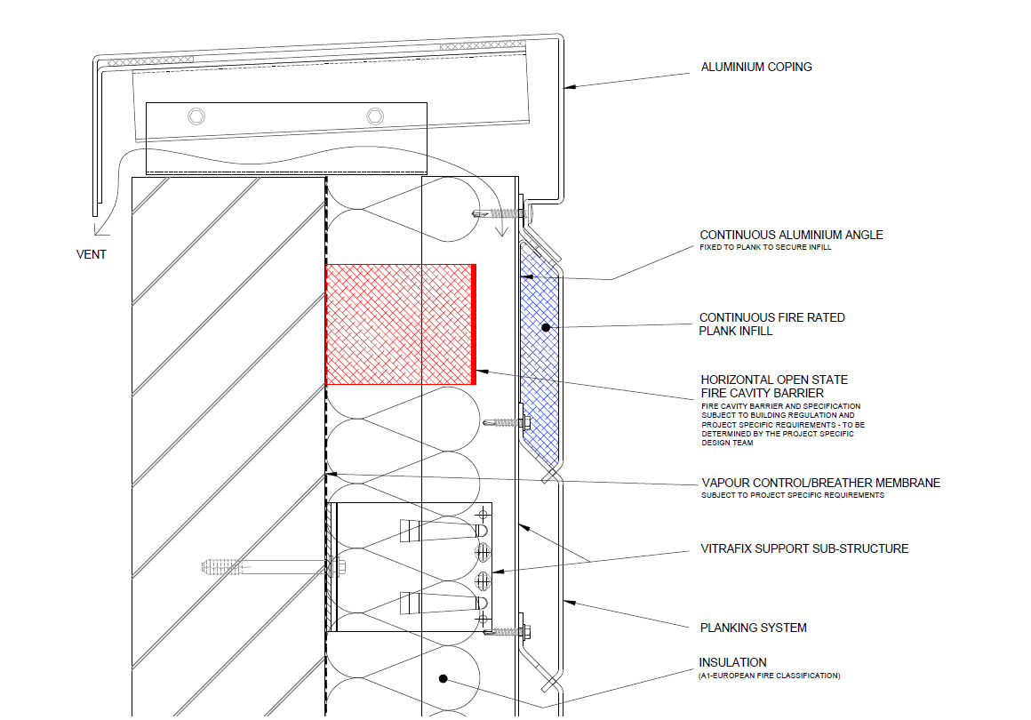
INTERLOCKING PLANK SYSTEM TYPICAL SECTION WINDOW HEAD
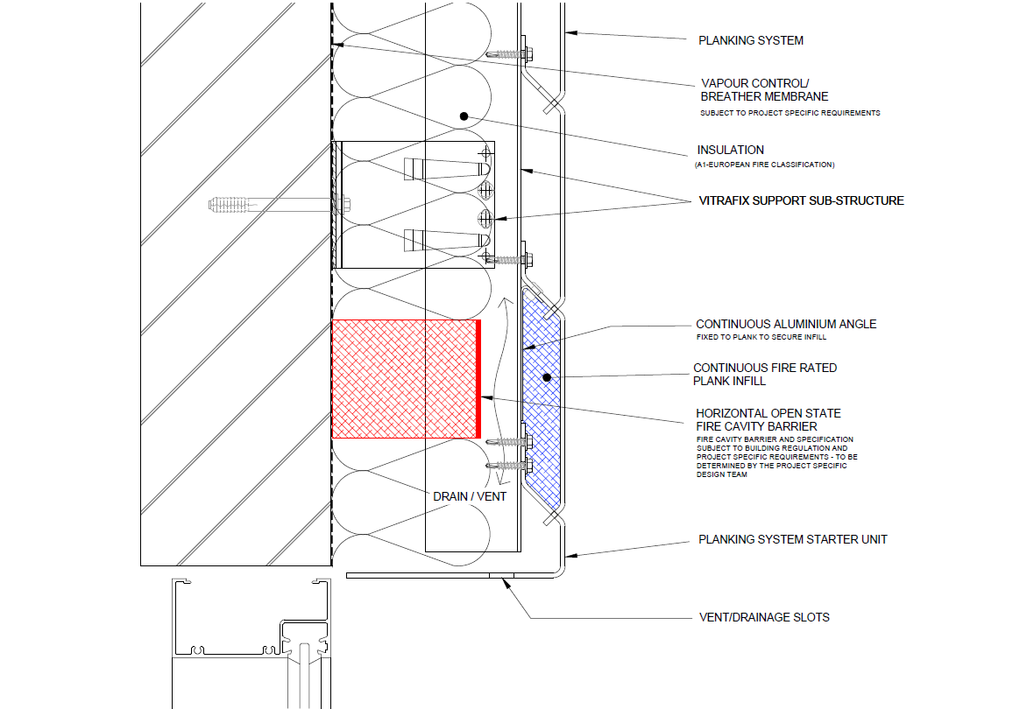

INTERLOCKING PLANK SYSTEM EXTERNAL CORNER
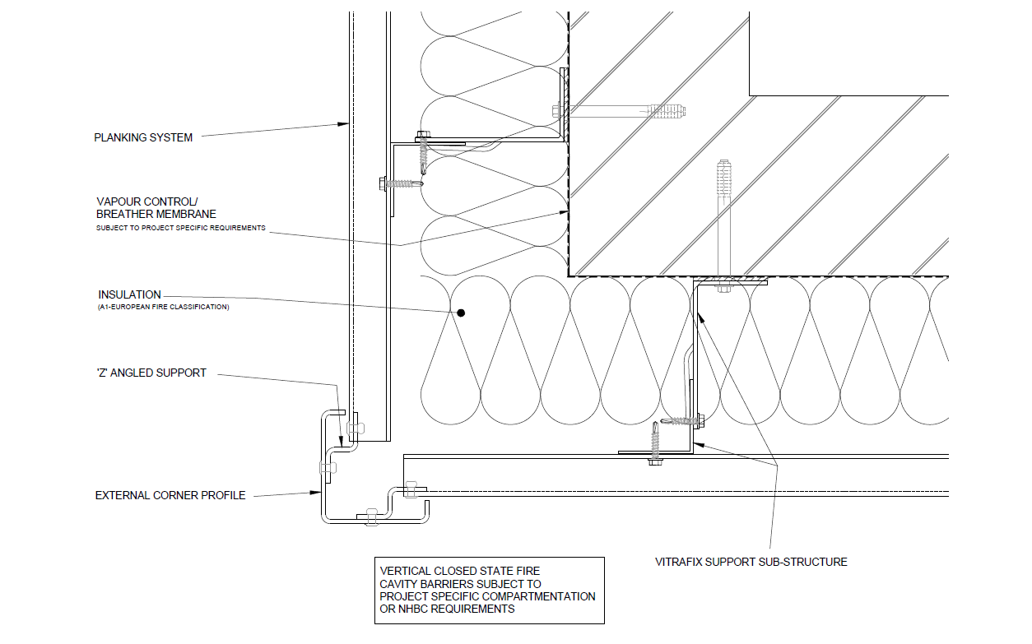
INTERLOCKING PLANK SYSTEM INTERNAL CORNER
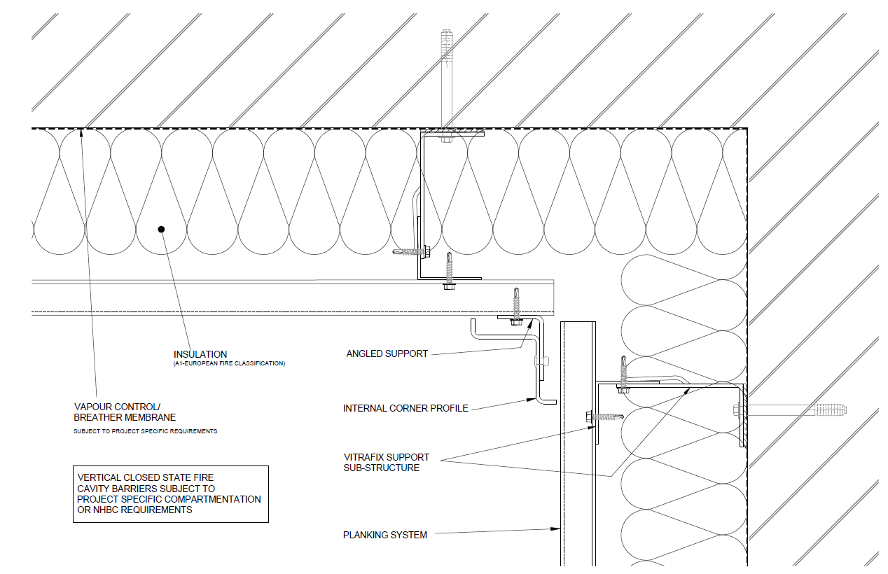
All Technical Details can be found at www.valcan.co.uk or on request by contacting enquiries@valcan.co.uk

TECHNICAL SCHEDULE
Purpose of this schedule
This Technical Schedule provides a structured summary of the principal components and performance intent of the VitraDual Interlocking Plank Rainscreen System. It is intended to support detailed design coordination, specification and installation.
Final system configuration, component selection, fixing centres and bracket spacing shall be confirmed through project-specific design, wind load calculations and manufacturer approval.
1. SYSTEM SUMMARY
- Façade system name: VitraDual Interlocking Plank Rainscreen System
- System type: Aluminium interlocking plank rainscreen façade system
- Primary carrier system: VitraFix VF1 aluminium bracket system
(VF2 secondary rails where required)
- Fire classification (overall system intent): A1
- Applicable standards: BS EN 13501-1, CWCT, BS 8414 (system tested)
(Informational summary only – see sections below for component detail)

2. PRIMARY CLADDING DETAILS
Product reference: VitraDual Interlocking Plank
Manufacturer: Fairview Europe t/a Valcan
Product name: VitraDual
Material: 5754 grade aluminium
Thickness and Weight:
- Thickness: 3mm / 2mm
- Weight (kg/m²): 8.13 kg/m².
Panel Dimensions:
- Indicative maximum plank lengths subject to wind loading, handling and manufacturer approval.
- Factory‑formed interlocking plank profile
- Standard and bespoke lengths available, subject to wind loading, handling and façade design
Fire Performance:
- Classification to BS EN 13501-1: Classified A1

3. PANEL FIXING
Fixing method: Concealed mechanical fixings located within the interlocking zone
Fixing visibility: No visible external fixings to the finished façade
Stiffening: Rear-mounted aluminium stiffeners may be incorporated where required to control deflection and support fixing loads
Stiffener attachment: Stud-welded or mechanically fixed to rear face of plank
Fixing centres: Subject to wind load calculations, plank length and manufacturer guidance
3.1 PRIMARY PANEL FIXINGS
 | Rail/fixing type | Reference | Sizes
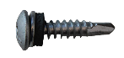 | Vitrafix Self-Drilling Pan-Head Screw. A4 stainless steel | VFSDP5.535C | 5.5 × 35 mm
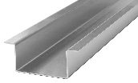 | Aluminium top-hat stiffeners |  | 2.0mm

APPLICATION
- Pan head screw: Used to mechanically fix interlocking planks through the concealed fixing zone into the VitraFix carrier rail. Fixings are fully concealed once adjacent planks are engaged.
Notes:
- Fixing centres and quantity are determined by plank length, wind loading and stiffener configuration.
- All panel fixings remain hidden within the interlock, maintaining a clean façade appearance.

4. CARRIER SYSTEM
System reference: VitraFix VF1
Material: Aluminium
Function: Adjustable primary support brackets for fixing to structural substrate
Typical adjustability: 102–235 mm
Bracket type and spacing: Determined by project-specific wind load and façade design

 | Bracket Reference | Size | Adjustment Range
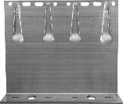 | VF140DB | 65 mm-260 mm double bracket | 142–172 mm
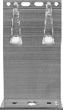 | VF140SB | 65mm-260 mm single bracket | 142–172mm
4.1 BRACKETS
Bracket selection and spacing subject to structural and wind load calculations.
 | Bracket Reference | Reference | Size
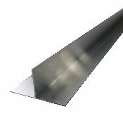 | T-Rails | VFTR503/ VFTR506 | 50 × 100 × 3000 mm  50 × 100 × 6000 mm
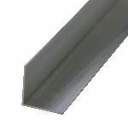 | L-Rails | VFLR503/ VFLR506 | 50 × 50 × 3000 mm  50 × 50 × 6000 mm
4.2 CARRIER RAILS
4.3 THERMAL/ISOLATION PADS
 | Bracket Reference | Size | Adjustment Range
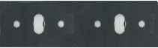 | VFIPDB | Double bracket thermal pad | 3 mm
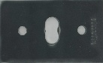 | VFIPSB | Single bracket thermal pad | 3mm

 | Type | Size | Reference
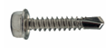 | Self-Drilling Hex-Head Screws | 4.8 × 25 mm | VFSD4.825/A4
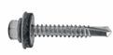 | Self-Drilling Hex-Head Screws with washer | 5.5 × 38 mm | VFSD.538/A4
4.4 CARRIER TO RAIL/RAIL TO BRACKET

5. JOINTS AND TOLERANCES
Joint type: The VitraDual system utilises a profiled interlocking plank joint. Individual planks mechanically engage with adjacent units to form a continuous horizontal façade with concealed fixings and consistent joint alignment.
Joint appearance: The interlocking profile creates a controlled, uniform joint between planks. Joint expression is inherent to the plank design, with no open vertical joints or visible fixings to the finished façade.
Fixing tolerance: Installation tolerances are accommodated through:
- The engagement of the interlocking plank profile, and
- Adjustment within the VitraFix carrier system brackets and rails
Final façade alignment is achieved through carrier system adjustment rather than movement at the panel face.
Thermal movement: Allowance shall be made for the thermal expansion and contraction of aluminium components. The interlocking plank design concealed fixing strategy and carrier system configuration shall accommodate movement without inducing stress, distortion or noise in the finished façade.
Installation tolerances: All tolerances to be controlled in accordance with manufacturer guidance and CWCT best practice. Any deviation from recommended tolerances shall be reviewed and approved by the manufacturer prior to installation.
6. CAVITY AND VENTILATION
Rainscreen principle: The VitraDual Interlocking Plank System is designed as a drained and ventilated rainscreen façade, allowing moisture to be managed behind the cladding layer and discharged safely from the system.
Cavity depth: A minimum cavity depth shall be maintained between the rear of the interlocking planks and the face of the insulation in accordance with CWCT guidance and the project fire strategy. Final cavity depth is determined by carrier system configuration, substrate tolerances and fire barrier requirements.
Reduced cavity zones:
Localised reductions in cavity depth may occur at:
- Fire barrier locations
- Structural or façade “pinch points”
Any reduction in cavity depth shall be detailed to maintain continuity of drainage, ventilation and fire performance.

Ventilation strategy: Ventilation of the cavity is achieved through the rainscreen build-up and detailing at the base and head of the façade, in accordance with CWCT best practice and project detailing.
Coordination: Cavity depth, ventilation openings and interface details shall be fully coordinated with insulation, fire barriers, breather membranes and carrier system components to ensure performance is maintained throughout the façade.
7. ANCILLARY COMPONENTS
7.1 SHEATHING BOARDS
- Product reference: ProcellaPro A1 Sheathing Board
- Panel size: 2500 x 1250mm
- Thickness/weight: 12 mm / 21.6 kg/m²
- Fire Rating to BS EN 13501-1: A1
- Manufacturer: Fairview Europe t/a Valcan
7.2 FIXINGS
 | Rail/fixing type | Reference | Sizes
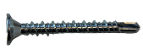 | VitraFix Self Drill ProcellaPro WT fixing | VFSDPP4.838/WT | 4.8x38mm

7.3 FIRE BARRIERS
Product reference:
- Open‑state horizontal cavity fire barriers
- Non‑ventilated vertical fire barriers
Fire performance: Designed to maintain cavity compartmentation and prevent fire spread within the rainscreen cavity, in accordance with the project fire strategy and Approved Document B (ADB v2).
Manufacturer: Valcan partner manufacturer of fire barriers
Fixings: Fire tested fixings to be advised by Valcan to equivalent performance of fire barrier, fixing reference dictated by substrate.
7.4 BREATHER MEMBRANE
- Product reference: Valcan partner manufacturer Breather Membrane
- Fire performance (BS EN 13501-1): A1 or A2

7.5 INSULATION
- Product reference: Valcan partner manufacturer of insulation
- Thickness: TBC
- Thermal Performance: 0.034 w/mK
- Fire performance (BS EN 13501-1): A1

9. MASONRY FIXINGS (IF REQUIRED)
Masonry / Concrete Fixings:
- ETA-approved, fire-rated fixings
- Pull-out testing to confirm suitability by Valcan partners
10. COORDINATION AND QUALIFICATIONS
- All interfaces with windows, doors, movement joints and adjacent systems to be fully coordinated at detailed design stage.
- Final fixing layouts, bracket spacing and component selection subject to manufacturer’s calculations and approval.
- Installation to be carried out in accordance with manufacturer’s current installation guidance.

TECHNICAL DOWNLOADS
VitraDual Product Brochure April 2026
VitraDual (3mm) BBA Certification
VitraDual (3mm) Efectis Fire Classification Report
VitraDual (2-3mm) Warrington Fire Classification Report
VitraDual Rivet & Rivet CWCT Certification
VitraDual 5754 Grade CCPI Verification Details
VitraDual EPD Certificate
VitraDual Typical Drawings
VitraFix Product Brochure – July 2025
VitraFix Typical Drawings


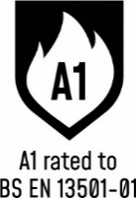



ADDITIONAL RESOURCES & SUPPORT
REGISTER FOR OUR FREE ACCREDITED CPD SEMINARS  Valcan offer free CPD sessions throughout the year which are dedicated to sharing our experiences and helping you to make the correct choices for your building projects.  The CPD program explains the safe cladding solutions available and how to comply with current regulations and illustrates the correct build ups to achieve the government standards. | 
ON-SITE TOOLBOX TALKS  Valcan Toolbox Talks are delivered on site to support safe, compliant installation and reinforce best practice throughout the construction process. These sessions provide clear, practical guidance on system installation, handling, and building safety considerations, helping ensure consistent standards, informed operatives and a strong on‑site safety culture. | 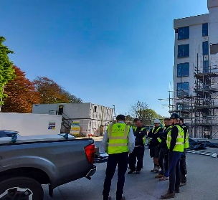
ORDER FREE PRODUCT SAMPLES  Order up to three free samples from our website. See them up close, compare finishes, and find the perfect match for your next project with confidence. We offer colour-matching services for your specific needs. Provide us with the code or a sample and we'll match it while meeting your design requirements. | 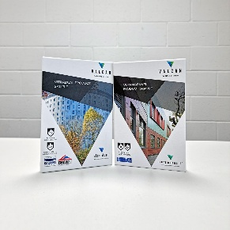
TECHNICAL SERVICES  Valcan offer a wide range of technical services to support project design and system installation. In depth NBS Specifications, project specific CAD drawings, photographic overlays, U-values and condensation / humidity risk analysis documents are all readily available via our website. | 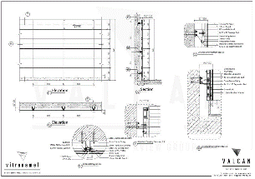
QUALITY, ENVIRONMENTAL AND INFORMATION STANDARDS  Valcan is certified to ISO 9001 and ISO 14001, confirming independently audited quality and environmental management systems that support consistent performance and responsible operations. The organisation is also CCPI Verified, demonstrating a commitment to clear, accurate and transparent construction product information in line with current building safety expectations. |   

For more information visit www.valcan.co.uk/support/ or contact the team on:
01278 428245 or email enquiries@valcan.co.uk

FAIRVIEW EUROPE T/A VALCAN
Dunball House, Woodlands Court Business Park
Bristol Road, Bridgwater, Somerset TA6 4FJ
Telephone: 01278 428245
Email: enquiries@valcan.co.uk
Web: www.valcan.co.uk



