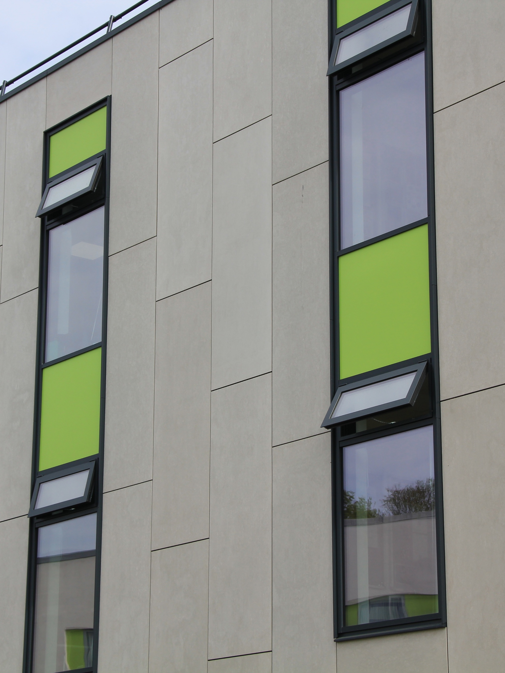



Specifications for NBS Chorus
Ceramapanel & VitraFix (VF1/VF2) Secret Fix System



SUMMARY
System name: Ceramapanel Secret Fix Rainscreen System
System basis of design: Ceramapanel A1 fibre cement panels installed on the VitraFix carrier system.
Manufacturer: Valcan with approved partner system components.
System type: A1 fibre cement secret fix rainscreen façade.
Fixing method: Concealed Mechanical Secret Fix
Fire rating: A1 throughout (panels, carrier system, insulation and membrane).
Warranty: Up to 15 years.
Typical applications: Residential, commercial, industrial and high-rise buildings.
Standards: BS 8414 tested carrier system, CWCT assessed, EN 12467 fibre cement classification.



CONTENTS
CERAMAPANEL A1 FIBRE CEMENT SECRET FIX RAINSCREEN SYSTEM | P 4-5
System description
Panel description
Performance
Finish and colour
Technical Characteristics
Application
Specifiers notes – Ceramapanel | P 5
VITRAFIX ALUMINIUM CARRIER SYSTEM OVERVIEW | P 7-8
System description
Performance and compliance
System options
Application
Specifiers notes - VitraFix | P8
TYPICAL DRAWINGS | P 9-10
Secret fix vertical joint
Secret fix horizontal joint
Secret fix external corner
Secret fix internal corner
TECHNICAL SCHEDULE | P 11 – 15
System summary
Primary cladding details
Panel Fixings and stiffening
Carrier System – Primary Support
Horizontal rails (if required)
Joints and tolerances
Cavity and ventilation
Ancillary components
Masonry fixings (if required)
TECHNICAL DOWNLOADS | P 16
ADDITIONAL RESOURCES | P 17
Contact details | P 18

CERAMAPANEL A1 FIBRE CEMENT RIVET FIX RAINSCREEN SYSTEM
SYSTEM DESCRIPTION
Ceramapanel is a through-coloured compressed fibre cement rainscreen façade system comprising concealed mechanically fixed fibre cement panels installed using undercut anchors and VitraFix VF3 secret fix brackets onto an aluminium support structure.
The secret fix system provides a clean, uninterrupted façade appearance by concealing all panel fixings from view whilst maintaining the durability, weather resistance and performance characteristics expected of a modern ventilated rainscreen façade.
The complete system is available with a comprehensive warranty when supplied and installed in accordance with manufacturer's recommendations.
PANEL DESCRIPTION
Ceramapanel is a through-coloured compressed fibre cement façade panel available in a range of thicknesses and finishes.
Material: Compressed fibre cement
Thickness options:
- 8 mm
- 10 mm
- 12 mm
Fire Classification: A1 to BS EN 13501-1
Fixing method: Concealed mechanical fixing using undercut anchors and VitraFix VF3 secret fix brackets.
Appearance: Through-coloured panel providing a natural and consistent appearance throughout the panel thickness.
PERFORMANCE
Fire Performance: A1 non-combustible classification.
Durability: Resistant to rot, corrosion, termites, moisture and UV exposure.
Acoustic Performance: Natural sound dampening characteristics.
Impact Resistance: High strength and impact resistant.
Environmental Exposure: Suitable for temperature ranges from -20°C to +60°C.
Service Life: Long-lasting façade solution requiring minimal maintenance.
Warranty: Up to 15 years subject to specification compliance and installation in accordance with Valcan requirements.

TECHNICAL CHARACTERISTICS
Density: 1600 kg/m³ (±50)
Thermal Conductivity: 0.42 W/mK
Vapour Resistance Factor: 320 µ
Durability Classification: Category A to EN 12467
Strength Classification:
- Class 4 (untreated sheets)
- Class 5 (treated sheets)
Compressive Strength: 40 MPa
Bending Strength (Dry):
- Longitudinal: 32 MPa
- Transversal: 22 MPa
Modulus of Elasticity (Dry):
- Longitudinal: 14 GPa
- Transversal: 12 GPa
Modulus of Elasticity (Wet):
- Longitudinal: 11 GPa
- Transversal: 9 GPa
FINISH AND COLOUR
Ceramapanel is available in a wide range of colours and textures with a through-coloured finish. Colour and finish selection should be confirmed at enquiry stage.
Finish Options:
- Natural
- Contour Lines
- Touch
Colour Range: Standard and bespoke colours available.
Special Features:
- Through-coloured construction
- Graffiti-resistant options available through Natural+ treatments
- Low maintenance finish
- UV stable appearance

APPLICATION
Secret fix installation is particularly suited to projects where a premium façade appearance is required with no visible face fixings. The system is commonly specified on residential, commercial, education and public sector developments where architectural aesthetics are a key consideration
Typical applications include:
- Residential developments
- High-rise residential buildings
- Commercial offices
- Educational facilities
- Healthcare buildings
- Industrial developments
- Mixed-use projects
Particularly suited where a natural façade appearance is desired whilst maintaining non-combustible performance.

Specifiers notes:
Undercut Anchors: Undercut anchors shall be installed in accordance with the anchor manufacturer's recommendations and approved drilling procedures.
VF3 Brackets: VF3 brackets shall be positioned in accordance with project-specific structural calculations.
Panel Geometry: Minimum panel dimensions and edge distances shall comply with secret fix system requirements.
Wind Loading: Final fixing layouts remain subject to project-specific structural calculations.
Cavity Requirements: Minimum cavity requirements shall be maintained in accordance with CWCT guidance and project fire strategy

VITRAFIX ALUMINIUM CARRIER SYSTEM OVERVIEW
The following carrier system details describe a typical aluminium support system suitable for mechanically fixed A1 rainscreen façades, illustrated using the VitraFix carrier system.

SYSTEM DESCRIPTION
VitraFix is an aluminium carrier system comprising brackets, rails and fixings designed to support non-combustible rainscreen façade systems.
The system has been tested to BS 8414-1 and BS 8414-2 and assessed in accordance with CWCT requirements. It provides an adjustable and durable support structure suitable for a wide variety of substrates and building types.

PERFORMANCE AND COMPLIANCE
Fire performance: Tested to BS 8414-1 and BS 8414-2 as part of an external wall system.
Structural assessment: CWCT tested (subject to project-specific calculations).
Durability: Aluminium components designed for long-term external use.
Warranty: A system warranty is available when specified and installed in accordance with manufacturer’s requirements.

SYSTEM OPTIONS
VitraFix VF1 – Primary Bracket System
VitraFix VF1 is an adjustable aluminium bracket system designed to accommodate variations in substrate tolerance and cavity depth.
- Adjustability: 102–235 mm
- Application: Direct bracket fixing to structural substrate
- Extensions: Additional depth may be achieved by incorporating the VitraFix VF2 system components.
- Options: Custom bracket depths are available subject to project requirements.
VF1 is typically used as the primary carrier system for rivet-fixed rainscreen façades.

VitraFix VF2 – Rail and Secondary Support System
VitraFix VF2 comprises aluminium or steel top-hats and C-channel rails designed to provide additional system depth or allow brackets to be installed independently of stud locations.
- Enables alignment of the carrier system where stud positions are restrictive
- Can be used to increase overall system build-up depth
- Top-hats may be used independently as an alternative to timber batten sub-grids
VF2 components may be used in conjunction with VF1 brackets or as part of a secondary support arrangement, subject to design requirements.
VitraFix VF3 – Secret Fix Support System
VitraFix VF3 is a concealed fixing system for Ceramapanel façade panels. The system utilises undercut anchors installed into the rear face of the panel to secure VF3 fixing brackets. The brackets engage onto horizontal VF3 rails fixed back to the primary carrier system.
VF3 enables a completely concealed façade fixing arrangement, removing the requirement for visible face fixings whilst providing a secure and structurally tested installation method.
The top row of VF3 brackets is used to level and dead-fix the panel position, with remaining brackets allowing for movement and load transfer as required by the system design
APPLICATION
The VitraFix carrier system is suitable for use with non-combustible rainscreen façade systems on residential, commercial and mixed-use buildings. Final system selection, bracket spacing and fixing strategy shall be determined by project-specific structural and wind load calculations.

Specifier’s Notes:
Bracket type, spacing and material selection to be confirmed based on substrate, cavity depth and wind load calculations.
Movement joints and tolerance allowances to be incorporated in façade design to accommodate thermal expansion, substrate movement and building deflection.

TYPICAL DETAILS
Details shown are indicative only and shall be developed to suit project‑specific geometry, substrate and fire strategy.
SECRET FIX DETAILS SHOWING VERTICAL JOINT
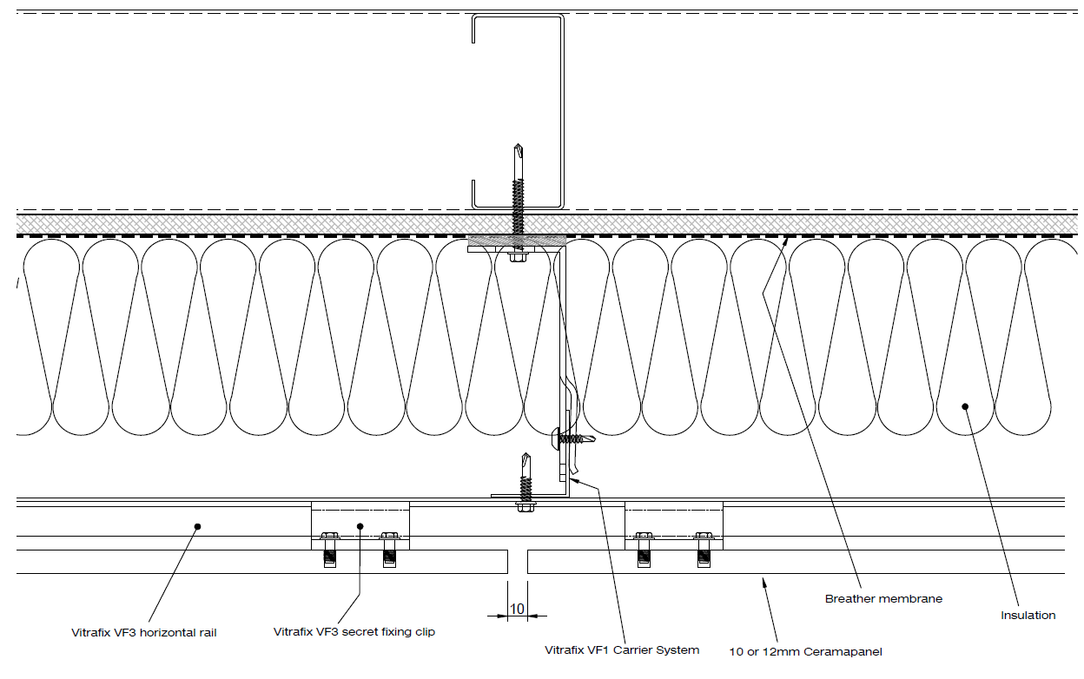
SECRET FIX DETAILS SHOWING HORIZONTAL JOINT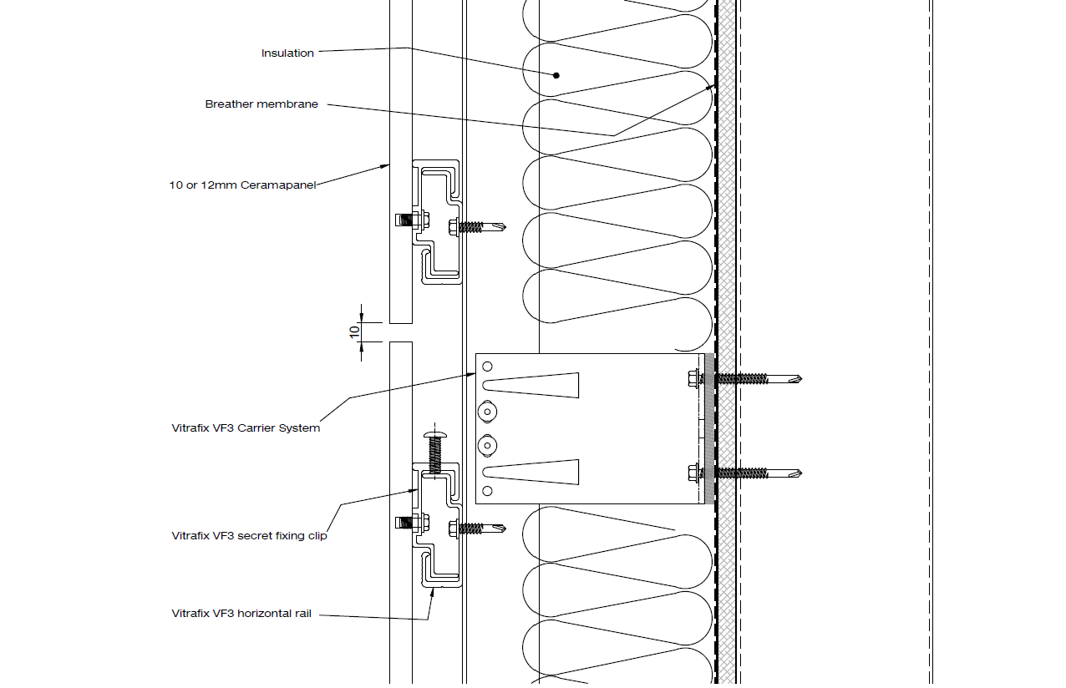

SECRET FIX DETAILS SHOWING EXTERNAL CORNER
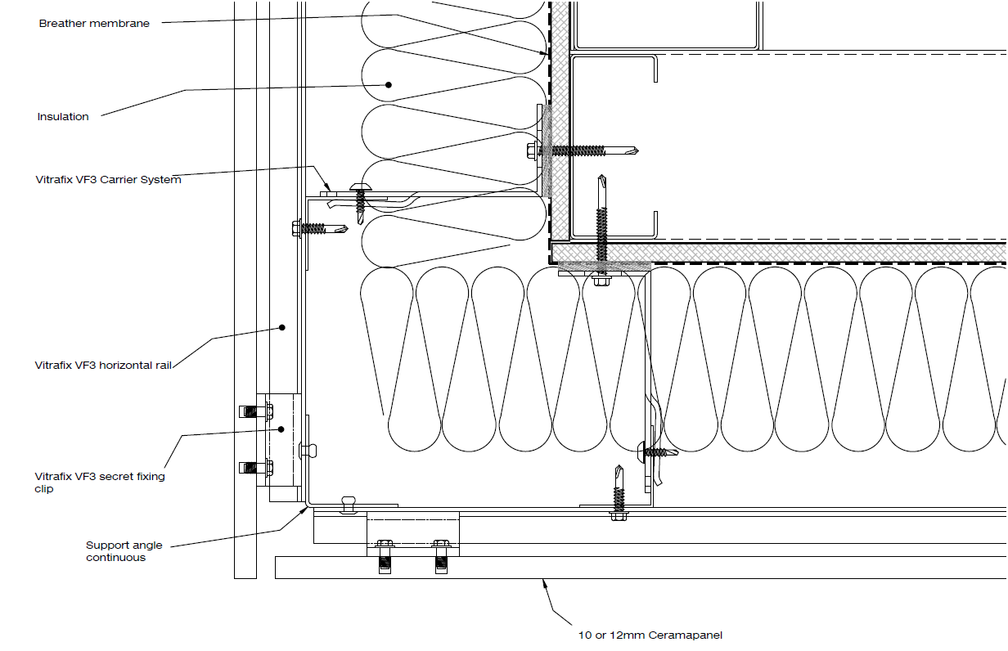
SECRET FIX DETAILS SHOWING INTERNAL CORNER
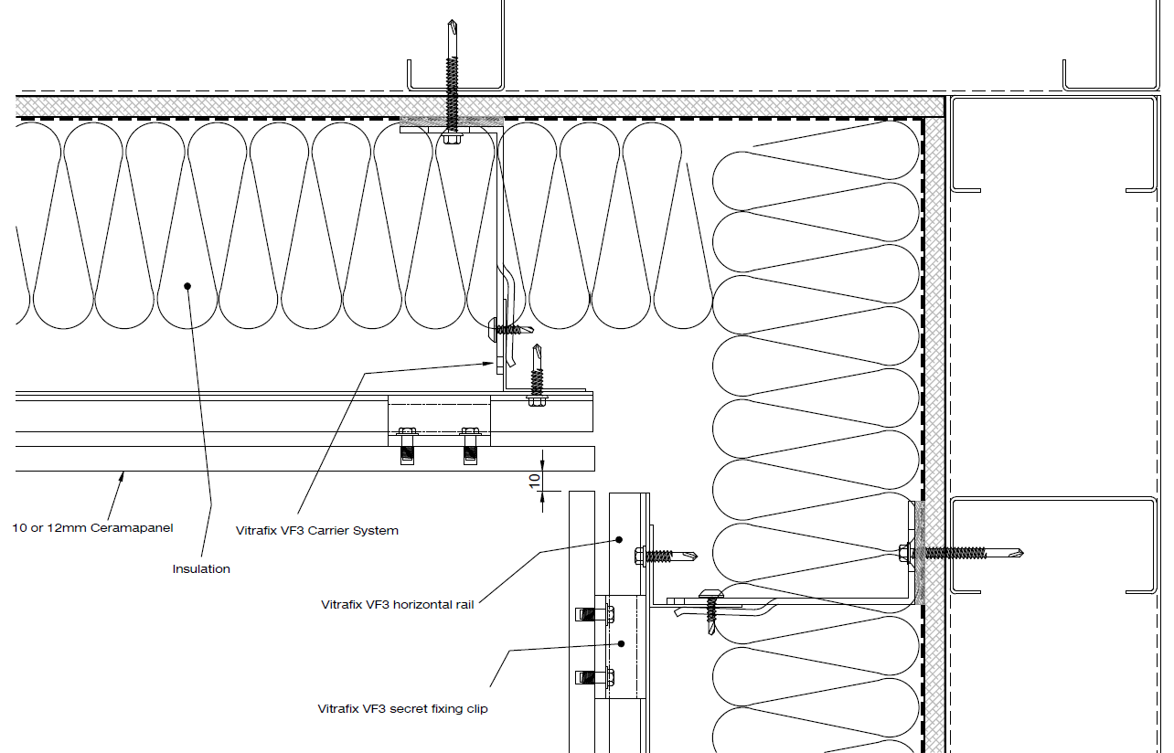
All Technical Details can be found at www.valcan.co.uk or on request.
TECHNICAL SCHEDULE
Purpose of this schedule
This Technical Schedule provides detailed system components and reference information to support detailed design, coordination and installation.
Final configuration, sizing and fixing arrangements shall be confirmed by project-specific calculations and manufacturer approval.
1. SYSTEM SUMMARY
Façade system name: Ceramapanel Secret Fix System
System type: Fibre Cement Secret Fix Rainscreen Façade
Primary carrier system: VitraFix VF1 / VF2 / VF3
Fire classification: A1
Applicable standards: BS EN 13501-1, EN 12467, CWCT, BS 8414
(Informational summary only – see sections below for component detail)

2. PRIMARY CLADDING DETAILS
Product Reference: Ceramapanel
Manufacturer: Fairview Europe t/a Valcan
Material: Through-coloured compressed fibre cement
Thickness and Weight:
- Thickness: 8mm / 10mm / 12mm
- Weight (kg/m²): 14.4 kg/m² / 18.0 kg/m² / 21.6 kg/m²
Panel Dimensions:
- 2500 x 1250mm / 3050 x 1250mm
- Panels supplied as flat sheets.
Fire Performance:
- Classification to BS EN 13501-1: Classified A1

3. PANEL FIXING
3.1 PRIMARY PANEL FIXINGS
 | Rail/fixing type | Description | Sizes
 | Undercut Anchor | Concealed rear-fixed anchor system
 | VF3 Secret Fix Bracket | Concealed support bracket
 | VF3 Secret Fix Rail | Horizontal aluminium support rail

Specification: Undercut anchors shall be installed to the rear of the Ceramapanel panel in accordance with the fixing manufacturer's installation requirements. VF3 brackets shall connect the panel to the horizontal VF3 rail system, providing a fully concealed fixing arrangement.
4. CARRIER SYSTEM
Carrier system reference: VitraFix VF1 / VF3
- Manufacturer: Fairview Europe t/a Valcan
Material: Aluminium
System Description: Adjustable aluminium bracket and rail carrier system providing structural support to the Ceramapanel façade whilst maintaining the required ventilation cavity.
 | Bracket Reference | Size | Adjustment Range
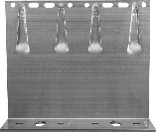 | VF140DB | 65 mm-260 mm double bracket | 142–172 mm
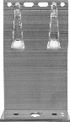 | VF140SB | 65mm-260 mm single bracket | 142–172mm
 |  | VitraFix VF3 Secret Fix Bracket – Fixed
 |  | VitraFix VF3 Secret Fix Bracket – Sliding
4.1 BRACKETS
Bracket references shown are indicative only and subject to project-specific structural calculations.
4.2 THERMAL/ISOLATION PADS
 | Bracket Reference | Size | Adjustment Range
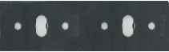 | VFIPDB | Double bracket thermal pad | 3 mm
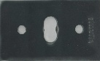 | VFIPSB | Single bracket thermal pad | 3mm

5. HORIZONTAL RAILS
System reference: VitraFix VF2 / VF3
Purpose: VF2/U attached to SFS locations allowing brackets to be installed in isolation to stud location
Typical Applications: Not required for masonry
5.1 RAILS AND FIXINGS
 | Rail/fixing type | Reference | Sizes
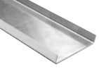 | U-Rail | VF2/U | 90x15x2mm / 174x15x2mm
 | Secret Fix Rail (VF3) | VFSRCR6 | 6m
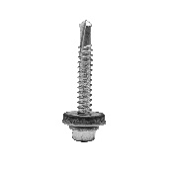 | VitraFix Self Drill Hex head with washer | VFSD.538/A4 | 5.5x38mm
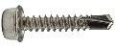 | VitraFix Self Drill Hex head | VFSD4.825 (See manufacturers details for fixing centres) | 4.8x25mm, 8mm

6. JOINTS AND TOLERANCES
Joint Widths:
- 8–10 mm open joints
- Closed joint options available
Joint Accessories:
- CFBB/65 Birdsmouth closure profile
- Vermin closures
- Vitrafix EPDM rail tape as required.

7. CAVITY AND VENTILATION
Open Joint Installation
- Minimum cavity depth: 50 mm measured from insulation face to panel rear.
Closed Joint Installation
- Minimum cavity depth: 25 mm measured from insulation face to panel rear.
- Ventilation requirements shall comply with CWCT recommendations and project fire strategy.

8. ANCILLARY COMPONENTS
8.1 SHEATHING BOARDS
- Product reference: ProcellaPro
- Panel size: 2500 x 1250mm
- Thickness/weight: 12 mm / 21.6 kg/m²
- Fire Rating to BS EN 13501-1: A1
- Manufacturer: Fairview Europe t/a Valcan
8.2 FIXINGS
 | Rail/fixing type | Reference | Sizes
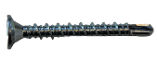 | VitraFix Self Drill ProcellaPro WT fixing | VFSDPP4.838/WT | 4.8x38mm

8.3 FIRE BARRIERS
Product reference:
- Open state horizontal barrier
- Non-ventilated vertical barrier
Fire performance:
- Insulation: TBC
- Integrity: TBC
Manufacturer: Valcan partner manufacturer of fire barriers
Fixings: Fire tested fixings to be advised by Valcan to equivalent performance of fire barrier, fixing reference dictated by substrate.

8.4 BREATHER MEMBRANE
- Product reference: Valcan partner manufacturer Breather Membrane
- Fire performance (BS EN 13501-1): A1 or A2
8.5 INSULATION
- Product reference: Valcan partner manufacturer of insulation
- Thickness: TBC
- Thermal Performance: 0.034 w/mK
- Fire performance (BS EN 13501-1): A1

9. MASONRY FIXINGS (IF REQUIRED)
Masonry / Concrete Fixings:
- ETA-approved, fire-rated fixings
- Pull-out testing to confirm suitability by Valcan partners
10. COORDINATION AND QUALIFICATIONS
- All interfaces with windows, doors, movement joints and adjacent systems to be fully coordinated at detailed design stage.
- Final fixing layouts, bracket spacing and component selection subject to manufacturer’s calculations and approval.
- Installation to be carried out in accordance with manufacturer’s current installation guidance.

TECHNICAL DOWNLOADS
Ceramapanel Brochure – May 2025
Ceramapanel Installation Manual – March 2023
Ceramapanel Data Sheet
Ceramapanel CCPI Schedule of Verified Product Information
Ceramapanel A2 Painted Data Sheet
Ceramapanel EPD
European Technical Assessment
Typical Drawings
Ceramapanel A1 Fire Classification Report
Ceramapanel A1 Printed Fire Classification Report (Gloss)
Ceramapanel A1 Printed Fire Classification Report (Matt)
Ceramapanel CWCT Technical Report
Ceramapanel A1 UKCA DoP
Ceramapanel A2 UKCA DoP

ADDITIONAL RESOURCES & SUPPORT
REGISTER FOR OUR FREE ACCREDITED CPD SEMINARS  Valcan offer free CPD sessions throughout the year which are dedicated to sharing our experiences and helping you to make the correct choices for your building projects.  The CPD program explains the safe cladding solutions available and how to comply with current regulations and illustrates the correct build ups to achieve the government standards. | 
ON-SITE TOOLBOX TALKS  Valcan Toolbox Talks are delivered on site to support safe, compliant installation and reinforce best practice throughout the construction process. These sessions provide clear, practical guidance on system installation, handling, and building safety considerations, helping ensure consistent standards, informed operatives and a strong on‑site safety culture. | 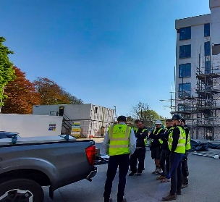
ORDER FREE PRODUCT SAMPLES  Order up to three free samples from our website. See them up close, compare finishes, and find the perfect match for your next project with confidence. We offer colour-matching services for your specific needs. Provide us with the code or a sample and we'll match it while meeting your design requirements. | 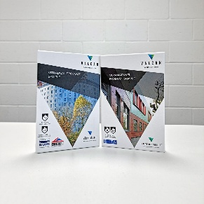
TECHNICAL SERVICES  Valcan offer a wide range of technical services to support project design and system installation. In depth NBS Specifications, project specific CAD drawings, photographic overlays, U-values and condensation / humidity risk analysis documents are all readily available via our website. | 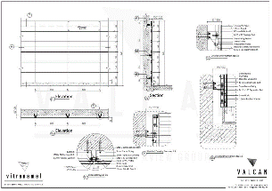
QUALITY, ENVIRONMENTAL AND INFORMATION STANDARDS  Valcan is certified to ISO 9001 and ISO 14001, confirming independently audited quality and environmental management systems that support consistent performance and responsible operations. The organisation is also CCPI Verified, demonstrating a commitment to clear, accurate and transparent construction product information in line with current building safety expectations. |   

For more information visit www.valcan.co.uk/support/ or contact the team on:
01278 428245 or email enquiries@valcan.co.uk

FAIRVIEW EUROPE T/A VALCAN
Dunball House, Woodlands Court Business Park
Bristol Road, Bridgwater, Somerset TA6 4FJ
Telephone: 01278 428245
Email: enquiries@valcan.co.uk
Web: www.valcan.co.uk

