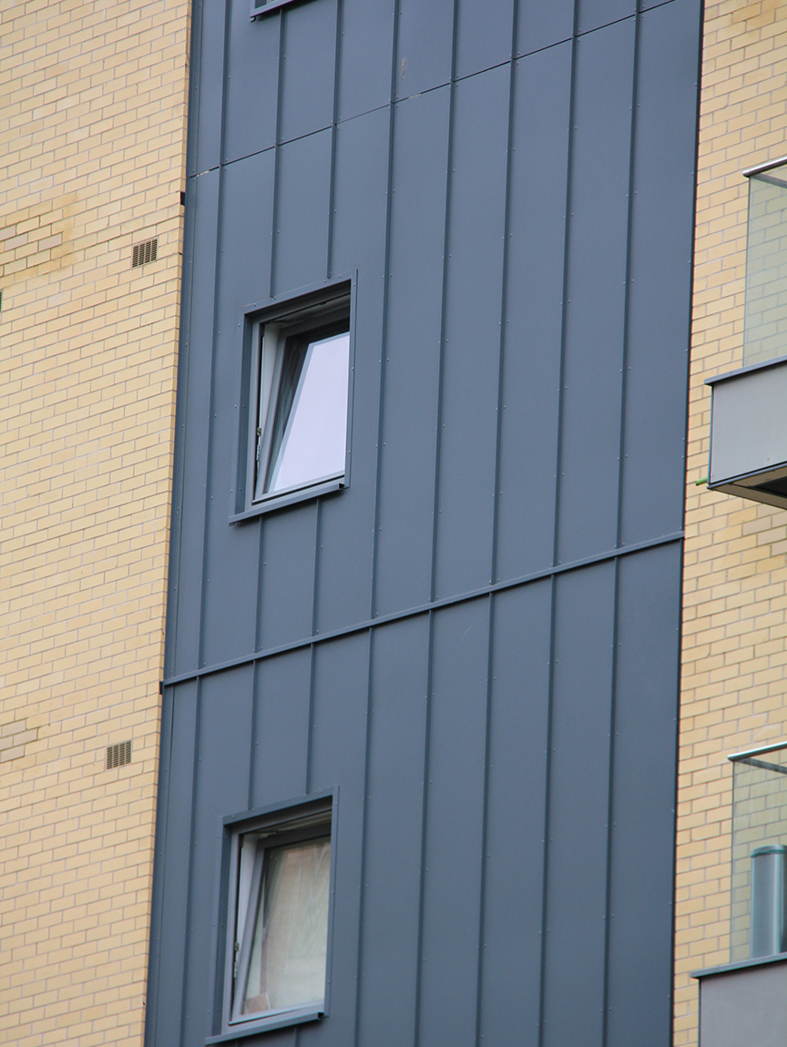



Specifications for NBS Chorus
VitraDual & VitraFix (VF1/VF2) Standing Seam Effect Rainscreen System



SUMMARY
System name: VitraDual Standing Seam Effect Rainscreen System
System basis of design: Profiled VitraDual A1 aluminium panels formed to Standing Seam geometry and installed on the VitraFix carrier system
Manufacturer: Valcan with approved partner system components
System type: A1 aluminium profiled rainscreen façade system
Fixing method: Face-fixed using colour-matched rivets aligned within the standing seam profile
Fire rating: A1 throughout (panels, carrier, insulation, membrane)
Warranty: Up to 30 years
Typical applications: Residential, commercial, feature façades
Standards: BS 8414-1 / BS 8414-2 tested, CWCT tested, BBA certified

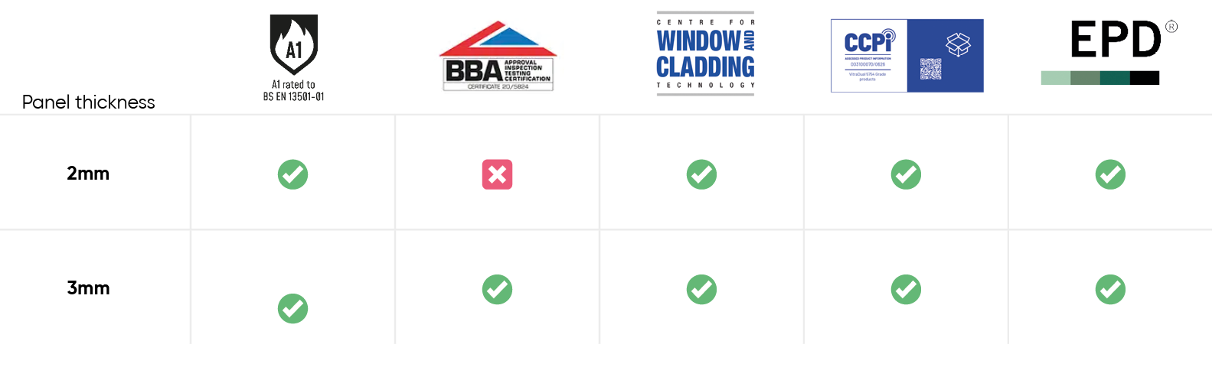

* Vitradual 3mm is manufactured by Valcan and is available with BBA certification when produced at BBA-certified production facilities. Certification requirements must be specified at enquiry and order stage. Contact us for more details

CONTENTS
VITRADUAL A1 ALUMINIUM STANDING SEAM EFFECT RAINSCREEN SYSTEM | P 4-6
System description
Panel description
Performance
Finish and colour
Application
Specifiers notes – VitraDual | P 6
VITRAFIX ALUMINIUM CARRIER SYSTEM OVERVIEW | P 7-8
System description
Performance and compliance
System options
Application
Specifiers notes - VitraFix | P 8
TYPICAL DRAWINGS | P 9
Standing Seam Effect system typical drawing
TECHNICAL SCHEDULE | P10
System summary
Primary cladding details
Panel Fixings and stiffening
Carrier System – Primary Support
Horizontal rails (if required)
Joints and tolerances
Cavity and ventilation
Ancillary components
Masonry fixings (if required)
TECHNICAL DOWNLOADS | P15
ADDITIONAL RESOURCES | P16
Contact details | P17

VITRADUAL A1 ALUMINIUM STANDING SEAM EFFECT RAINSCREEN SYSTEM
SYSTEM DESCRIPTON
VitraDual Standing Seam is a non-combustible rainscreen façade system utilising profiled solid aluminium panels designed to replicate the appearance of traditional standing seam cladding.
The system incorporates formed vertical seam profiles, creating a defined linear aesthetic while maintaining the performance, durability and fire classification of a solid aluminium rainscreen system.
Panels are mechanically fixed to an aluminium subframe using colour-matched rivets, with fixings located within designated zones to minimise visual impact.
The system is eligible for a single-point warranty when supplied and installed in accordance with manufacturer’s recommendations.

PANEL DESCRIPTION
VitraDual standing seam panels are manufactured from solid aluminium and formed into a profiled geometry.
- Material: Aluminium alloy (5754 marine grade)
- Thickness: 3.0 mm
- Fire classification: A1 to BS EN 13501-1
- Profile: Standing Seam Effect: 01, 02 or 03* (up to 30 mm raised seam profile)
- Panel form: CNC cut and formed panels from flat sheet
- Fixing method: Face-fixed rivet system through designated fixing zones
- Surface: Flat, rigid panels with low surface stress and minimal oil-canning
Panels are profiled to create expressed vertical seams, rather than functioning as interlocking plank systems.
Bespoke panel sizes and layouts are available subject to project requirements.

*See typical drawings on page 9 for standing seam effect installation methods.

PERFORMANCE
Fire performance:
A1 non-combustible system suitable for use in accordance with Approved Document B (Volume 2)
Wind loading:
CWCT tested to 3600 Pa safety load (subject to project-specific calculations)
Durability:
- High resistance to impact and mechanical damage
- Corrosion-resistant aluminium substrate
- Suitable for exposed and high-traffic areas
Certification:
BBA Certified (Certificate No. 20/5824 – 3 mm panels)
Final system performance is subject to project-specific structural design, fixing centres and façade engineering.
* Vitradual 3mm is manufactured by Valcan and is available with BBA certification when produced at BBA-certified production facilities. Certification requirements must be specified at enquiry and order stage. Contact us for more details

FINISH AND COLOUR
VitraDual panels are factory finished using high-performance coating systems:
- Coating: PVDF (KYNAR 500) or FEVE
- Performance: Excellent resistance to UV exposure, weathering and pollutants
- Colour range: Standard and bespoke colours available
Additional finishes may include specialist coatings (e.g. metallic or wood-effect), subject to project requirements.
Finished panels require minimal maintenance and should be cleaned in accordance with manufacturer’s guidance.
Final colour, gloss level and coating specification must be confirmed at enquiry stage to determine warranty terms.

APPLICATION
The system is suitable for use on external façades across:
- High-rise residential buildings
- Commercial developments
- Industrial buildings
- Feature elevations requiring a strong linear aesthetic
Particularly suited to projects requiring a standing seam appearance using a non-combustible material solution.

Specifiers notes:
Panel Layout:
Panel widths, lengths and seam spacing must be coordinated to achieve the desired façade appearance and comply with wind load requirements.
Visual Alignment:
Standing seam profiles must align consistently across the façade, including transitions across floor levels and adjacent elements.
Fixing Strategy:
Face-fixed using colour-matched rivets positioned within designated fixing zones to minimise visibility. Fixed and sliding points to be incorporated to allow for thermal movement.
Wind Loading:
Fixing centres and panel dimensions subject to project-specific structural calculations.
Cavity Depth:
To comply with CWCT guidance and project fire strategy.

VITRAFIX ALUMINIUM CARRIER SYSTEM OVERVIEW
SYSTEM DESCRIPTION
VitraFix is an aluminium carrier system comprising brackets, rails and associated fixings, designed to support non-combustible rainscreen façade systems, including profiled panel applications such as standing seam effect façades.
The system provides a durable, adjustable and structurally efficient support solution for a wide range of substrates and façade configurations.

PERFORMANCE AND COMPLIANCE
Fire performance: The VitraFix aluminium carrier system has been tested as part of complete external wall systems in accordance with BS 8414-1 and BS 8414-2 and is suitable for use in non-combustible façade constructions designed to meet Approved Document B (ADB v2).
Structural performance: The system has been assessed by the Centre for Window and Cladding Technology (CWCT). Bracket spacing, rail sizing and fixing requirements are subject to project-specific wind load calculations and façade design parameters.
Durability: Aluminium components are designed for long-term external exposure and provide high resistance to corrosion and environmental degradation when installed in accordance with manufacturer recommendations.
Compliance: Final system configuration, component selection and fixing strategy shall be confirmed through project-specific design, structural assessment and manufacturer approval. Installation to be carried out strictly in accordance with current VitraFix installation guidance.

SYSTEM OPTIONS
VitraFix VF1 – Primary Bracket System
VitraFix VF1 is an adjustable aluminium bracket system designed to accommodate substrate tolerance, façade alignment and variable cavity depths.
- Adjustable bracket system for direct fixing to the structural substrate
- Typical adjustability range: 102–235 mm
- Suitable for masonry, concrete and SFS substrates
- Custom bracket depths available subject to project requirements
VF1 is typically used as the primary support system for interlocking plank rainscreen façades.

VitraFix VF2 – Secondary Support System
VitraFix VF2 comprises aluminium rails and top-hat sections used to increase system depth or enable installation independent of stud locations.
- Allows brackets to be fixed independently of SFS stud positions
- Can be used to increase overall cavity depth
- Top-hat sections may be used as an alternative to traditional sub-grids
VF2 components may be used in conjunction with VF1 brackets or as part of a secondary support arrangement, subject to project-specific design and structural assessment.

APPLICATION
The VitraFix aluminium carrier system is suitable for use with non-combustible rainscreen façade systems on residential, commercial and mixed-use buildings, including high-rise applications.
The system is designed to accommodate a variety of substrates, including masonry, concrete and SFS construction, and can be configured to suit project-specific cavity depths, fixing constraints and façade geometry.
Final carrier system configuration, including bracket type, spacing, rail selection and fixing strategy, shall be determined through project-specific façade design, wind load calculations and coordination with the project fire strategy. Installation shall be carried out strictly in accordance with manufacturer guidance and approved construction details.

Specifier’s Notes:
Bracket type and spacing subject to structural calculations
System must accommodate thermal movement and building tolerances
Fixings to suit substrate and be verified through pull-out testing
Full coordination required with insulation, fire barriers and membranes

TYPICAL DETAILS
STANDING SEAM EFFECT SYSTEM TYPICAL DRAWING
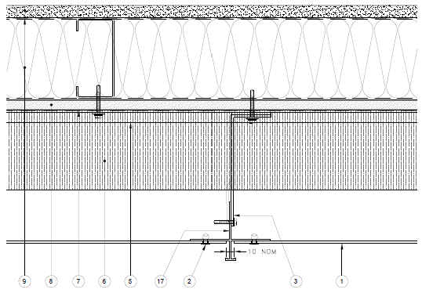

FIN RIVET FIX SYSTEM TYPICAL DRAWING
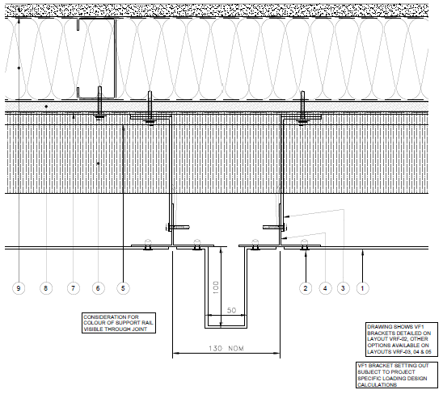

All Technical Details can be found at www.valcan.co.uk or on request by contacting enquiries@valcan.co.uk

TECHNICAL SCHEDULE
Purpose of this schedule
This Technical Schedule provides a structured summary of the principal components and performance intent of the VitraDual Standing Seam Effect Rainscreen System. It is intended to support detailed design coordination, specification and installation.
Final system configuration, component selection, fixing centres and bracket spacing shall be confirmed through project-specific design, wind load calculations and manufacturer approval.
1. SYSTEM SUMMARY
- Façade system name: VitraDual Standing Seam Effect Rainscreen System
- System type: Aluminium Standing Seam Effect rainscreen façade system
- Primary carrier system: VitraFix VF1 aluminium bracket system
(VF2 secondary rails where required)
- Fire classification (overall system intent): A1
- Applicable standards: BS EN 13501-1, CWCT, BS 8414 (system tested)
(Informational summary only – see sections below for component detail)

2. PRIMARY CLADDING DETAILS
Product reference: VitraDual Standing Seam Effect
Manufacturer: Fairview Europe t/a Valcan
Product name: VitraDual
Material: 5754 grade aluminium
Thickness and Weight:
- Thickness: 3mm
- Weight (kg/m²): 8.13 kg/m².
Panel Dimensions:
- Indicative maximum plank lengths subject to wind loading, handling and manufacturer approval.
- Profiled aluminium panels formed with raised standing seam geometry
- Standard and bespoke lengths available, subject to wind loading, handling and façade design
Fire Performance:
- Classification to BS EN 13501-1: Classified A1

3. PANEL FIXING
Fixing method: Face-fixed using colour-matched A4 stainless steel rivets, positioned within designated fixing zones aligned with the standing seam profile.

3.1 PRIMARY PANEL FIXINGS
 | Rail/fixing type | Reference | Sizes
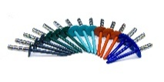 | Vitrafix A4 stainless steel rivet, colour matched to panel | VFR4.820C | 4.8 × 20 mm rivet

- Edge distance: 16–50 mm
- Fixing centres: Max. 600 mm (wind load dependant)
 | Type | Reference
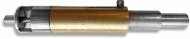 | Centralising Tool | VFCT74.9
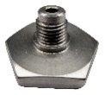 | Rivet Nosepiece Adapter (to prevent over tightening) | VFNPR/16
3.2 ACCESSORIES

4. CARRIER SYSTEM
Carrier system reference: VitraFix VF1
- Manufacturer: Fairview Europe t/a Valcan
Material: Aluminium
 | Bracket Reference | Size | Adjustment Range
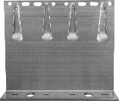 | VF140DB | 65 mm-260 mm double bracket | 142–172 mm
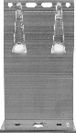 | VF140SB | 65mm-260 mm single bracket | 142–172mm
4.1 BRACKETS
Bracket selection and spacing to be confirmed by project-specific calculations.

4.2 THERMAL/ISOLATION PADS
 | Bracket Reference | Size | Adjustment Range
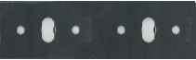 | VFIPDB | Double bracket thermal pad | 3 mm
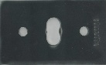 | VFIPSB | Single bracket thermal pad | 3mm

5. HORIZONTAL RAILS (IF APPLICABLE)
System reference: VitraFix VF2
Purpose: VF2/U attached to SFS locations allowing brackets to be installed in isolation to stud location
Typical Applications: Not required for masonry
5.1 RAILS AND FIXINGS
 | Rail/fixing type | Reference | Sizes
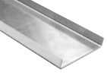 | U-Rail | VF2/U | 90x15x2mm / 174x15x2mm
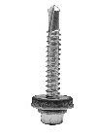 | VitraFix Self Drill Hex head with washer | VFSD.538/A4 | 5.5x38mm
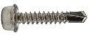 | VitraFix Self Drill Hex head | VFSD4.825 (See manufacturers details for fixing centres) | 4.8x25mm, 8mm

6. JOINTS AND TOLERANCES
Joint type: Open joints
Joint width: 8–10 mm
Configuration: Face-fixed using colour-matched rivets located within designated fixing zones aligned with the standing seam profile

7. CAVITY AND VENTILATION
Minimum cavity: 50 mm
- Measured from insulation face to rear of panel
- May be locally reduced at fire barriers
Ventilation:
Open-joint rainscreen in accordance with CWCT guidance
8. ANCILLARY COMPONENTS
8.1 SHEATHING BOARDS
- Product reference: ProcellaPro
- Panel size: 2500 x 1250mm
- Thickness/weight: 12 mm / 21.6 kg/m²
- Fire Rating to BS EN 13501-1: A1
- Manufacturer: Fairview Europe t/a Valcan
8.2 FIXINGS
 | Rail/fixing type | Reference | Sizes
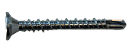 | VitraFix Self Drill ProcellaPro WT fixing | VFSDPP4.838/WT | 4.8x38mm

8.3 FIRE BARRIERS
Product reference:
- Open state horizontal barrier
- Non-ventilated vertical barrier
Fire performance:
- Insulation:
- Integrity:
Manufacturer: Valcan partner manufacturer of fire barriers
Fixings: Fire tested fixings to be advised by Valcan to equivalent performance of fire barrier, fixing reference dictated by substrate.

8.4 BREATHER MEMBRANE
- Product reference: Valcan partner manufacturer Breather Membrane
- Fire performance (BS EN 13501-1): A1 or A2
8.5 INSULATION
- Product reference: Valcan partner manufacturer of insulation
- Thickness: TBC
- Thermal Performance: 0.034 w/mK
- Fire performance (BS EN 13501-1): A1

9. MASONRY FIXINGS (IF REQUIRED)
Masonry / Concrete Fixings:
- ETA-approved, fire-rated fixings
- Pull-out testing to confirm suitability by Valcan partners
10. COORDINATION AND QUALIFICATIONS
- All interfaces with windows, doors, movement joints and adjacent systems to be fully coordinated at detailed design stage.
- Final fixing layouts, bracket spacing and component selection subject to manufacturer’s calculations and approval.
- Installation to be carried out in accordance with manufacturer’s current installation guidance.

TECHNICAL DOWNLOADS
VitraDual Product Brochure April 2026
VitraDual (3mm) BBA Certification
VitraDual (3mm) Efectis Fire Classification Report
VitraDual (2-3mm) Warrington Fire Classification Report
VitraDual Rivet & Rivet CWCT Certification
VitraDual 5754 Grade CCPI Verification Details
VitraDual EPD Certificate
VitraDual Typical Drawings
VitraFix Product Brochure – July 2025
VitraFix Typical Drawings

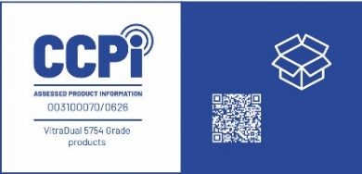
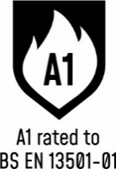
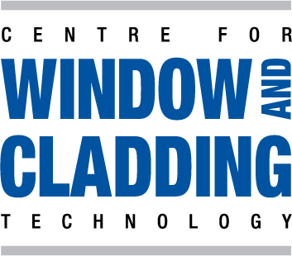


ADDITIONAL RESOURCES & SUPPORT
REGISTER FOR OUR FREE ACCREDITED CPD SEMINARS  Valcan offer free CPD sessions throughout the year which are dedicated to sharing our experiences and helping you to make the correct choices for your building projects.  The CPD program explains the safe cladding solutions available and how to comply with current regulations and illustrates the correct build ups to achieve the government standards. | 
ON-SITE TOOLBOX TALKS  Valcan Toolbox Talks are delivered on site to support safe, compliant installation and reinforce best practice throughout the construction process. These sessions provide clear, practical guidance on system installation, handling, and building safety considerations, helping ensure consistent standards, informed operatives and a strong on‑site safety culture. | 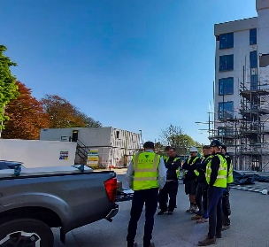
ORDER FREE PRODUCT SAMPLES  Order up to three free samples from our website. See them up close, compare finishes, and find the perfect match for your next project with confidence. We offer colour-matching services for your specific needs. Provide us with the code or a sample and we'll match it while meeting your design requirements. | 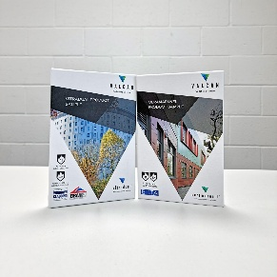
TECHNICAL SERVICES  Valcan offer a wide range of technical services to support project design and system installation. In depth NBS Specifications, project specific CAD drawings, photographic overlays, U-values and condensation / humidity risk analysis documents are all readily available via our website. | 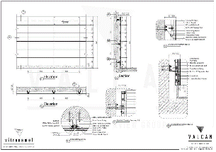
QUALITY, ENVIRONMENTAL AND INFORMATION STANDARDS  Valcan is certified to ISO 9001 and ISO 14001, confirming independently audited quality and environmental management systems that support consistent performance and responsible operations. The organisation is also CCPI Verified, demonstrating a commitment to clear, accurate and transparent construction product information in line with current building safety expectations. |   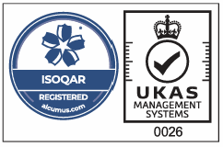

For more information visit www.valcan.co.uk/support/ or contact the team on:
01278 428245 or email enquiries@valcan.co.uk

CONTACTS
Façade Consultant – {Insert Name}
Telephone – {Insert direct number & mobile}
Email – {insertname}@valcan.co.uk

FAIRVIEW EUROPE T/A VALCAN
Dunball House, Woodlands Court Business Park
Bristol Road, Bridgwater, Somerset TA6 4FJ
Telephone: 01278 428245
Email: enquiries@valcan.co.uk
Web: www.valcan.co.uk

